**AMITY UNIVERSITY GWALIOR**

**(MADHYA PRADESH)**



**R PROGRAMMING PRACTICAL CSE - 322**

SESSION - 2020-24

SUBMITTED BY:- SUBMITTED TO:-

MR. RAJAT GUPTA DR. MADHVI DHINGRA

Btech (CSE) ASS. PROFESSOR (CSE)

ENROLLMENT NO:-

A60205220088

**1st**

c <-(1:2:3:4:5:6)

count <- 0

for(val in c){

if(val%%2==0){

print(paste(val,"even"))

}

else

{

print(paste(val,"odd"))

}

}

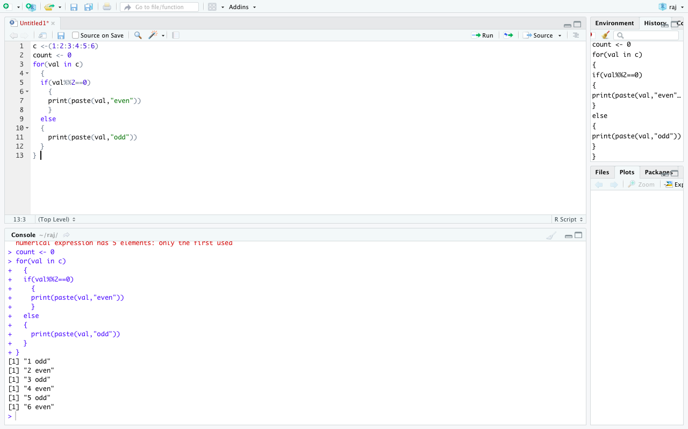

**2nd**

x<-10

y<-5

add<-function(x,y)

{

return(x+y)

}

subtract<-function(x,y)

{

return(x-y)

}

multiply<-function(x,y)

{

return(x*y)

}

divide<-function(x,y)

{

return(x/y)

}

print(paste("add",x,y,"is",add(x,y)))

print(paste("subtract",x,y,"is",subtract(x,y)))

print(paste("multiply",x,y,"is",multiply(x,y)))

print(paste("divide",x,y,"is",divide(x,y)))

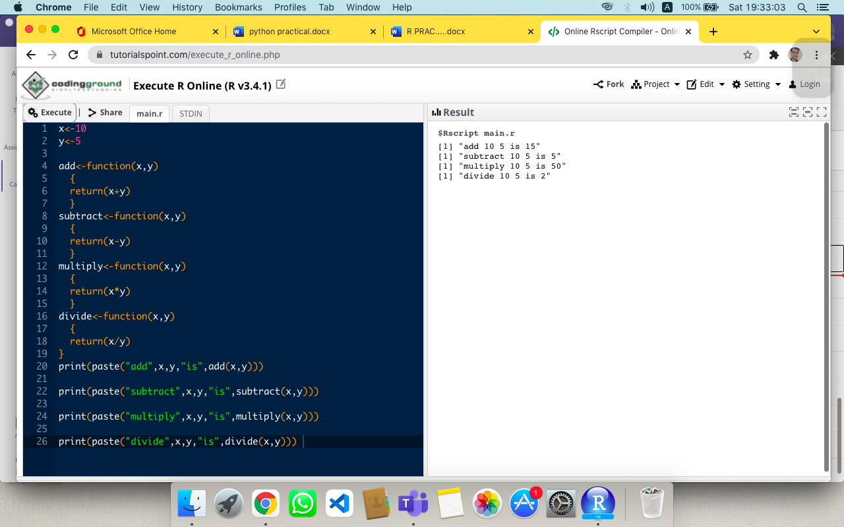

**3rd**

a <- c (8,22,38,14,25,6)

maximum=a[1]

for(i in a){

if(i>maximum)

maximum=i

}

maximum

minimum=a[1]

for(i in a){

if(i<minimum)

minimum=i

}

Minimum

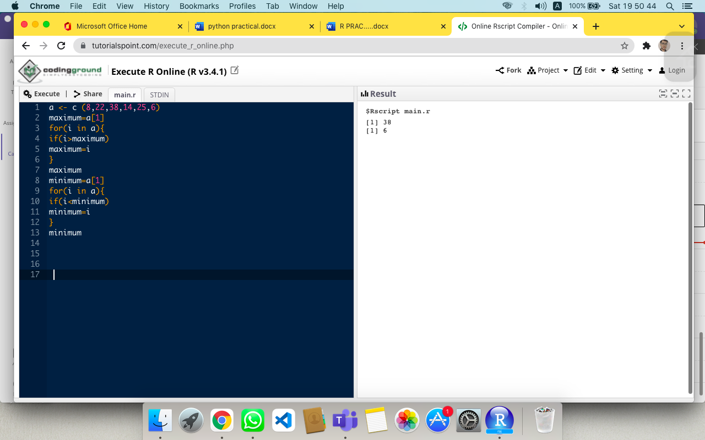

**4th**

list1=list(1,2,3,4,"rajat",c(5:7))

list1

typeof(list1)

length(list1)

list1[[6]]="ab"

list1

list1[[2]]=c(1:7)

list1

list1[[5]]=NULL

list1

list_tag=list("name"="rajat","age"=18,"course"="bachelor")

list_tag[[4]]=95

list_tag

list_tag[[4]]=NULL

list_tag[["Grade"]]="A"

list_tag

str(list_tag)

name(list_tag[[2]])="age"

list_tag

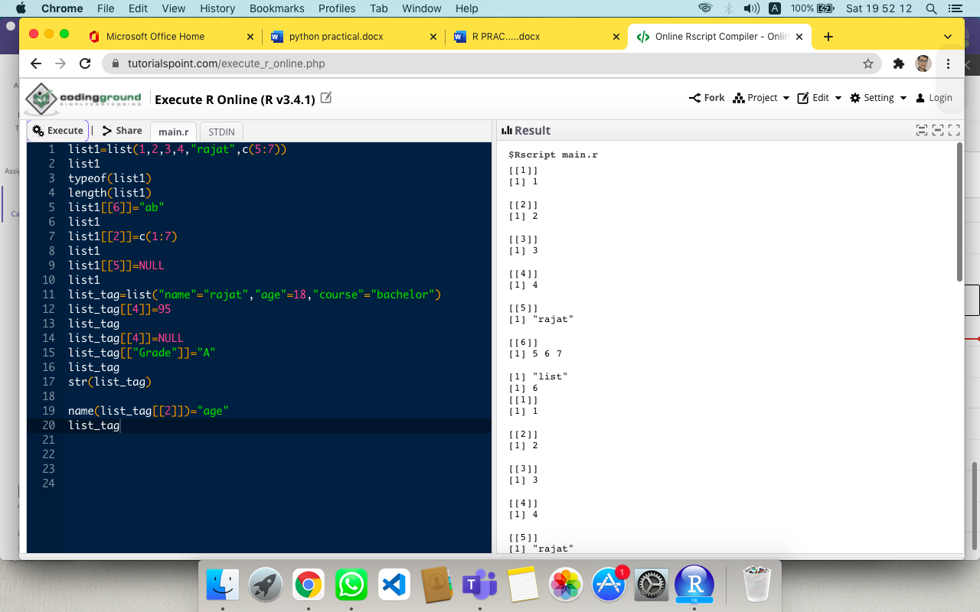

**5th**

list1=list(g1=1:10,g2="r programming",g3="html")

print("original list")

print(list1)

names(list1[[1]])="one"

names(list1[[2]])="two"

names(list1[[3]])="three"

print("Assign new names'one','two','three' to the element of the said list" )

print(list1)

str(list1)

list1$g1

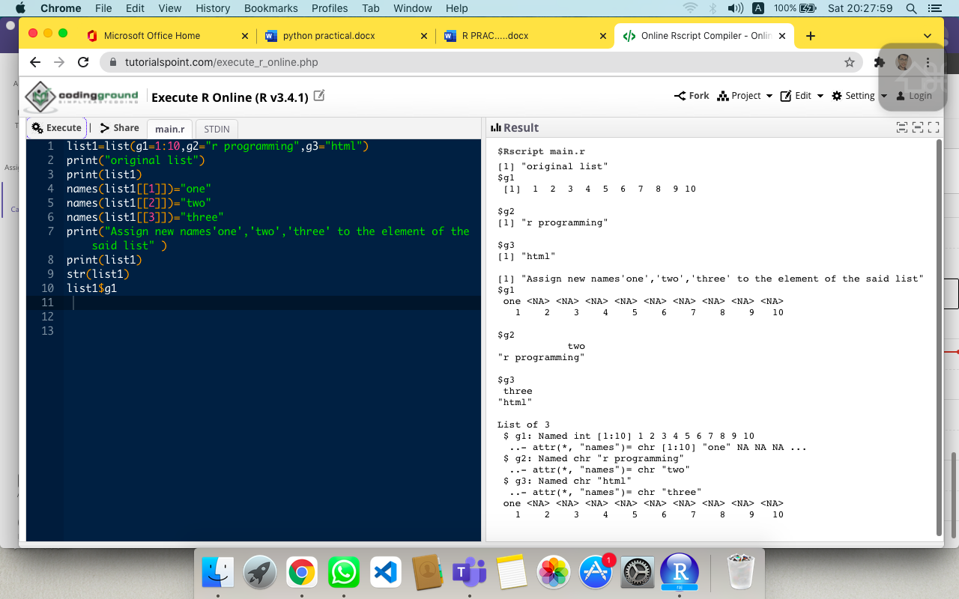

**6th**

n1=list(1,2,3)

c1= list("red","green","black")

print("original list ")

print(n1)

print(c1)

print("merge the said lists:")

mlist=c(n1,c1)

print("new merged list:")

print(mlist)

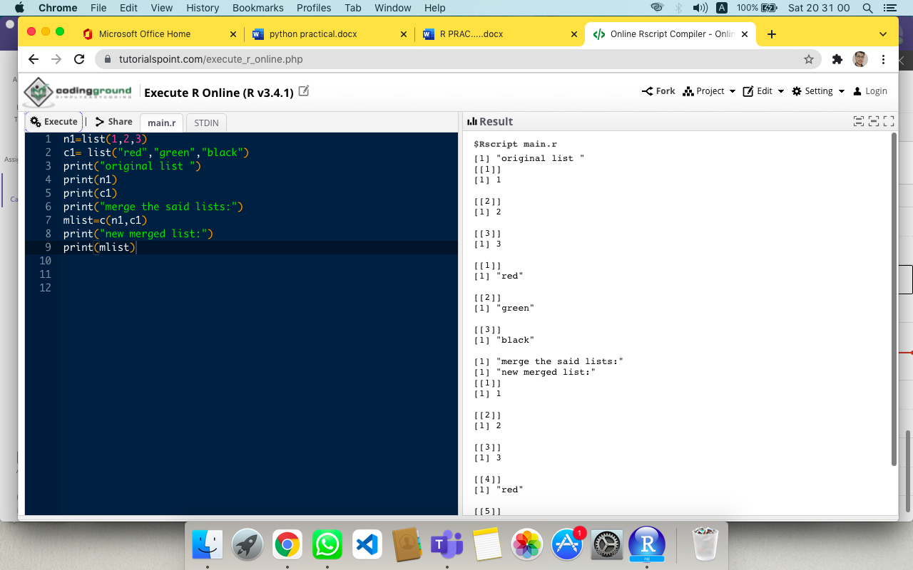

**7th**

m1=matrix(c(2,4,6,4,5,6),nrow=2)

print("matrix-1:")

print(m1)

m2=matrix(c(2,3,4,4,3,0),nrow=2)

print("matrix-2:")

print(m2)

result=m1+m2

print("result of addition")

print(result)

result=m1-m2

print("result of subtraction")

print(result)

result=m1*m2

print("result of multiplication")

print(result)

result=m1 / m2

print("result of addition")

print(result)

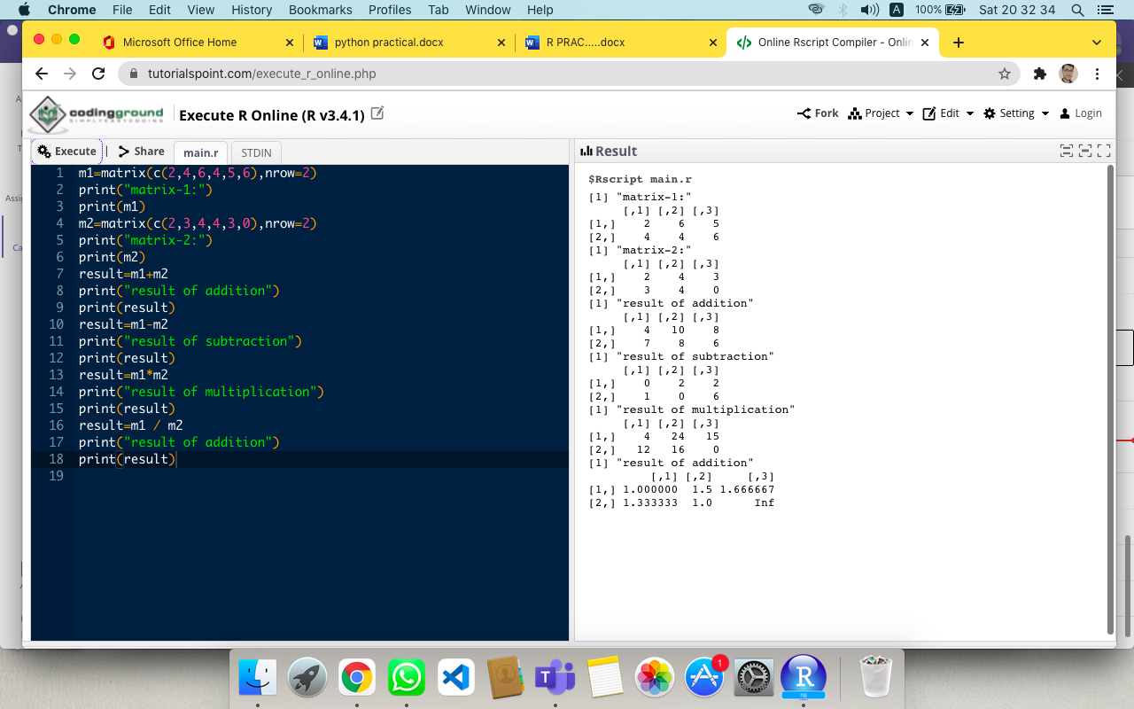

**8th**

#matrix creatn

matrix(1:9, nrow=3,ncol=3)

matrix(1:9, nrow=3)

x<-matrix(1:9, nrow=3,ncol=3 , dimnames = list(c("x","y","z"),c("A","B","C")))

#interesting fnctn

resut=x[x[,2]>4,]

print(resut)

#for check the representation

colnames(x)

rownames(x)

##for check the representation

colnames(x)<-c("c1","c2","c3")

rownames(x)<-c("r1","r2","r3")

X

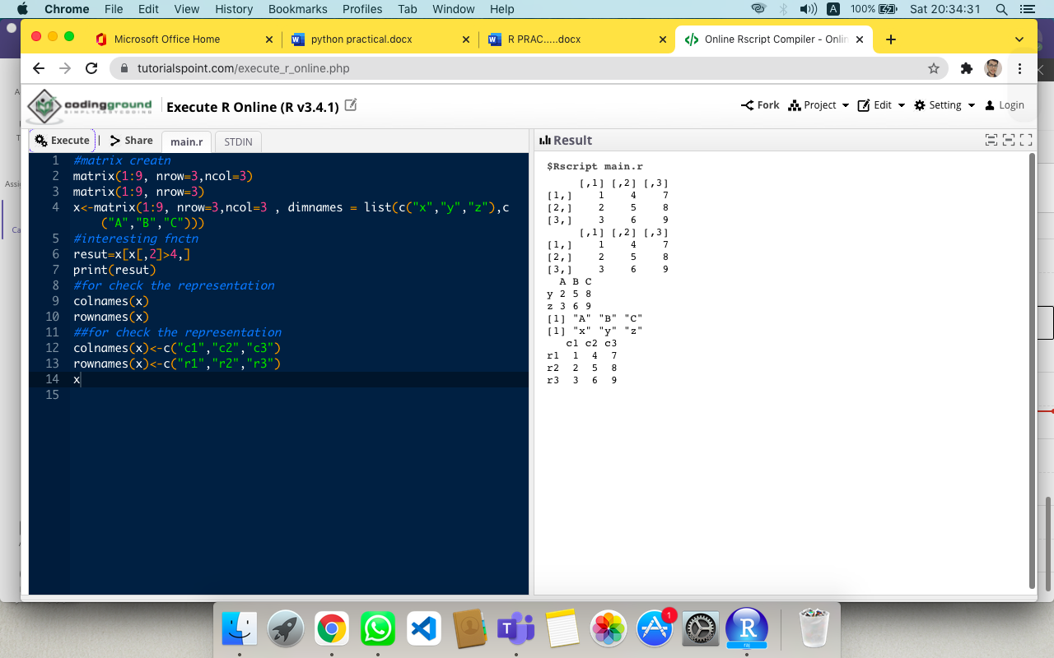

**9th**

#make matrix using these functn

cbind(c(1,2,3),c(4,5,6))

rbind(c(11,12,13),c(14,15,16))

# for change the dimension

y<-c(1,2,3,4,5,6)

y

dim(y)<-c(2,3)

y

# for sub matrix

z<-matrix(1:9, nrow=3,ncol=3)

z[c(1,2),c(2,3)]

z[c(3,2),]

# mdify the matrix

z[2,2]<-10;

z

z[z<6]<-1;

z

# for transpose

t(z)

cbind(z,c(1,2,3))

rbind(z,c(1,2,3))

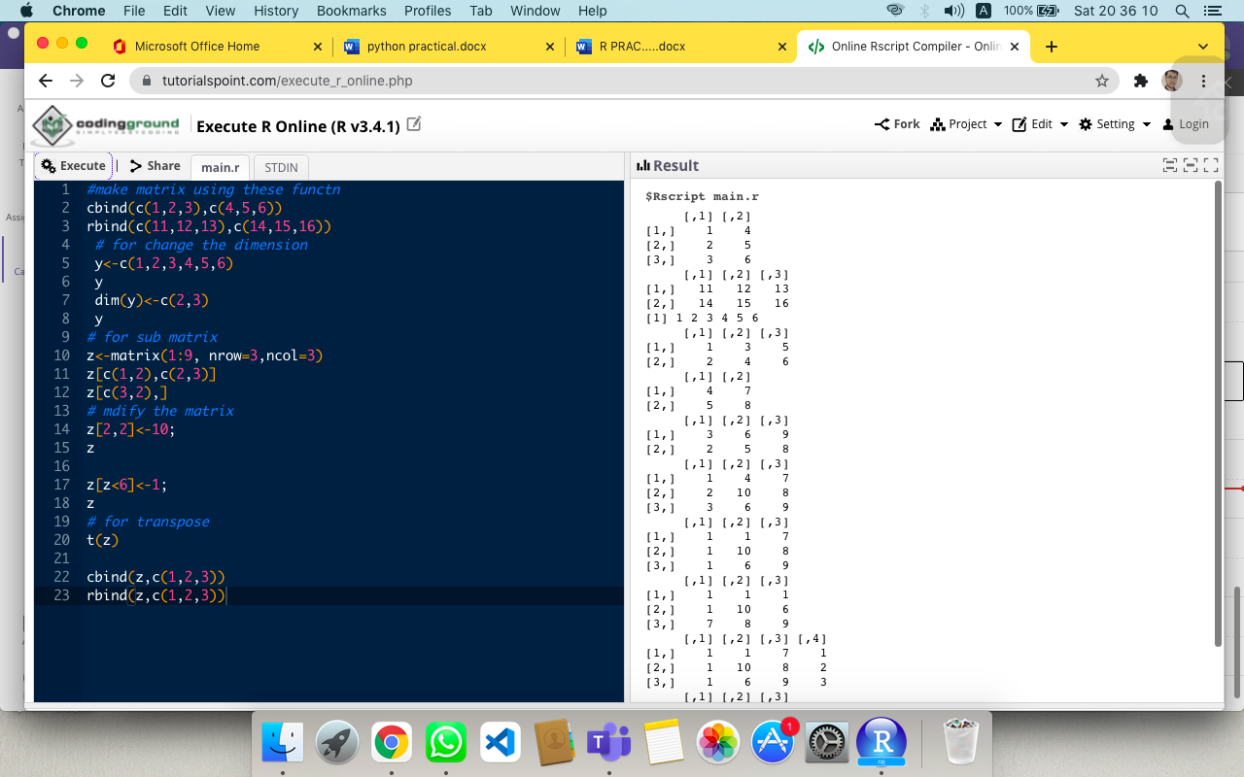

**10th**

m1=matrix(c(1:16),nrow=4,)

print("Original matrix")

print(m1)

result=which(m1==max(m1),arr.ind=TRUE)

print("Row and column of maximum value of matrix")

print(result)

max(m1)

result=which(m1==min(m1),arr.ind=TRUE)

print("Row and column of minimum value of matrix")

print(result)

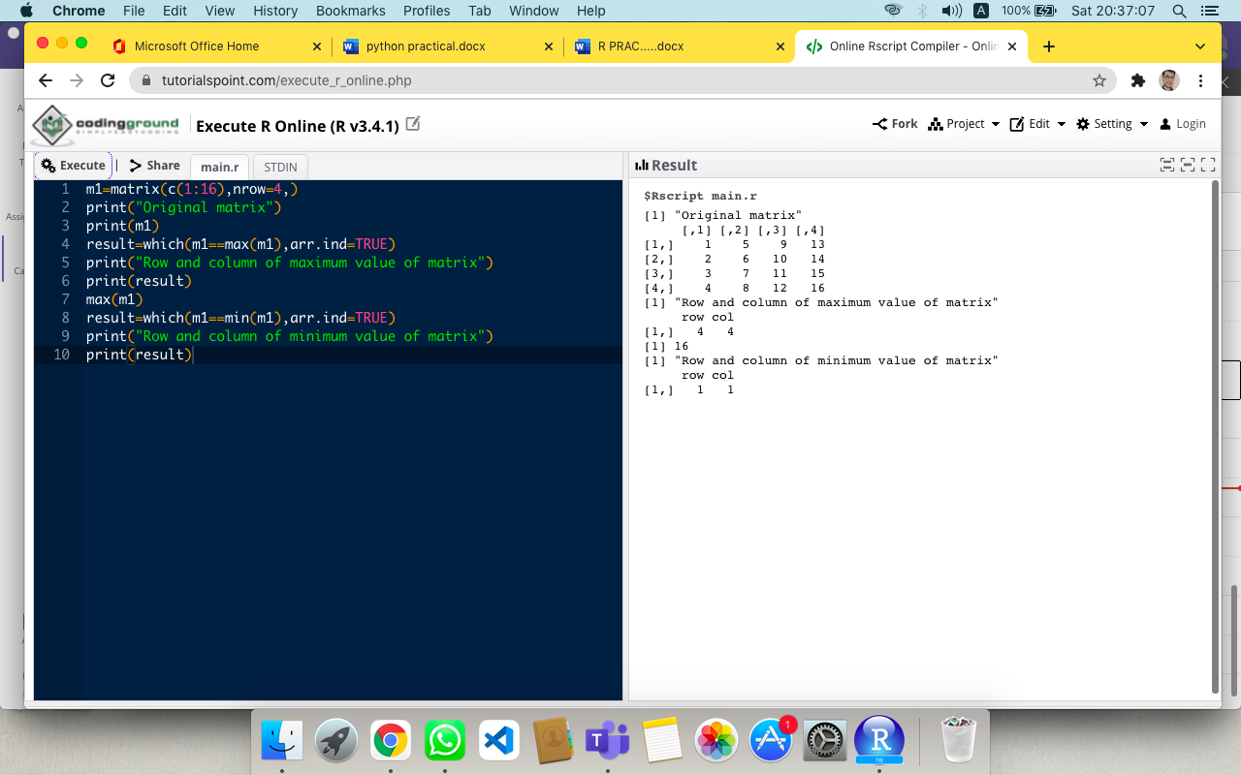

**11th**

m1=matrix(c(1:16),nrow=4,)

print("Original matrix")

print(m1)

result=as.vector(m1)

print("1 dimension matrix column wise")

print(result)

result=as.vector(t(m1))

print("1 dimension matrix row wise")

print(result)

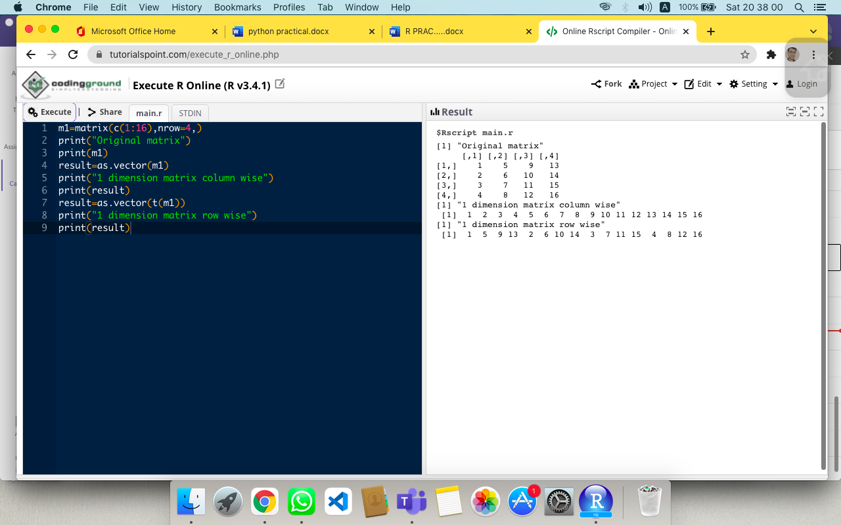

**12th**

m1=matrix(c(1:16),nrow=4,)

print("Original matrix")

print(m1)

m1=rbind(m1,c(4,4,4,4))

print(m1)

m1=cbind(m1,c(5,5,5,5))

print(m1)

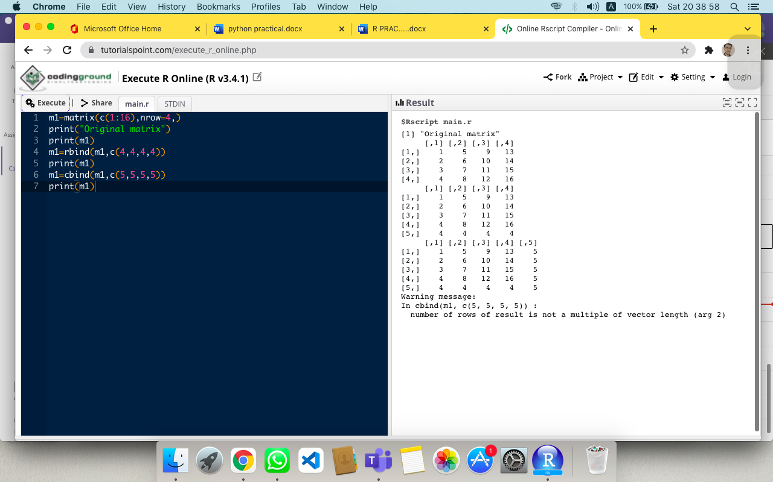

**13th**

x <- data.frame("SN" = 1:2, "Age" = c(18,6), "Name" = c("RAJAT","MANAS"))

#adding a cmpnent

rbind(x,list(1,22,"bhai"))

cbind(x,State=c("NY","FL"))

#multiple ways to access name

x["Name"]

x$Name

x[["Name"]]

#Accessing like a matrix

str(trees)

head(trees,n=3)

#acessing 2nd nd 3rd row

trees[2:3,]

trees[trees$Height > 82,]

trees[10:12,2]

x

#modify a Data Frame

x[1,"Age"] <- 20;

x

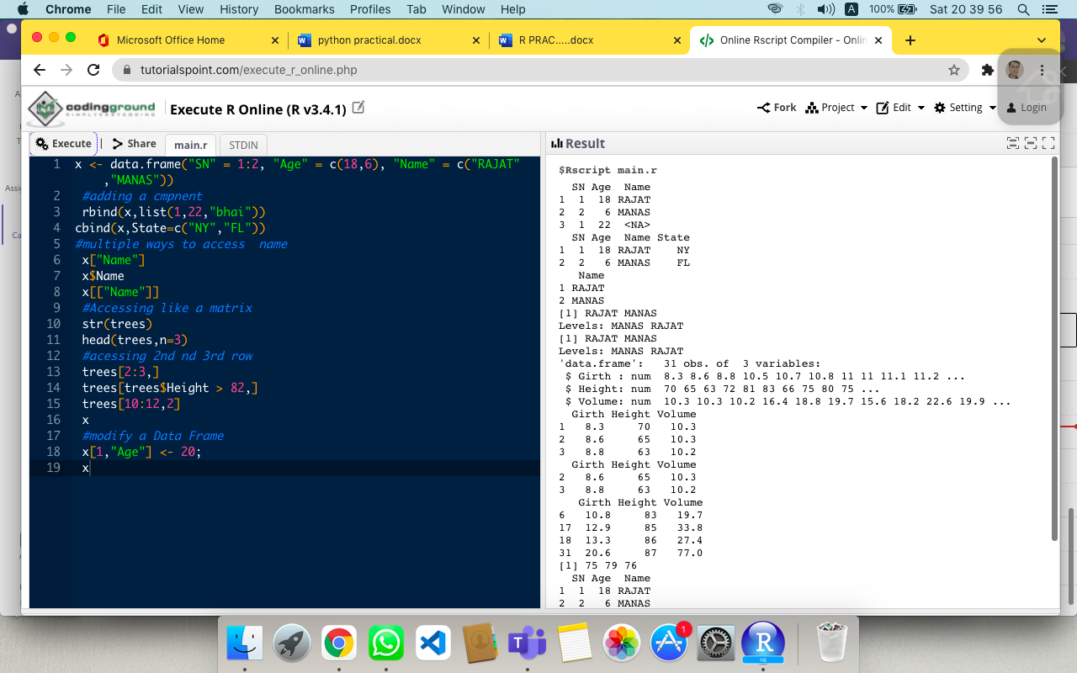

**14th**

x <- data.frame("SN" = 1:2, "Age" = c(18,6), "Name" = c("RAJAT","MANAS"))

#adding a cmpnent

cbind(x,State=c("NY","FL"))

#multiple ways to access name

x["Name"]

x$Name

x[["Name"]]

#Accessing like a matrix

str(trees)

head(trees,n=3)

#acessing 2nd nd 3rd row

trees[2:3,]

trees[trees$Height > 82,]

trees[10:12,2]

x

#modify a Data Frame

x[1,"Age"] <- 20;

x

#clear

x$Name <- NULL

x

x <- x[-1,]

x

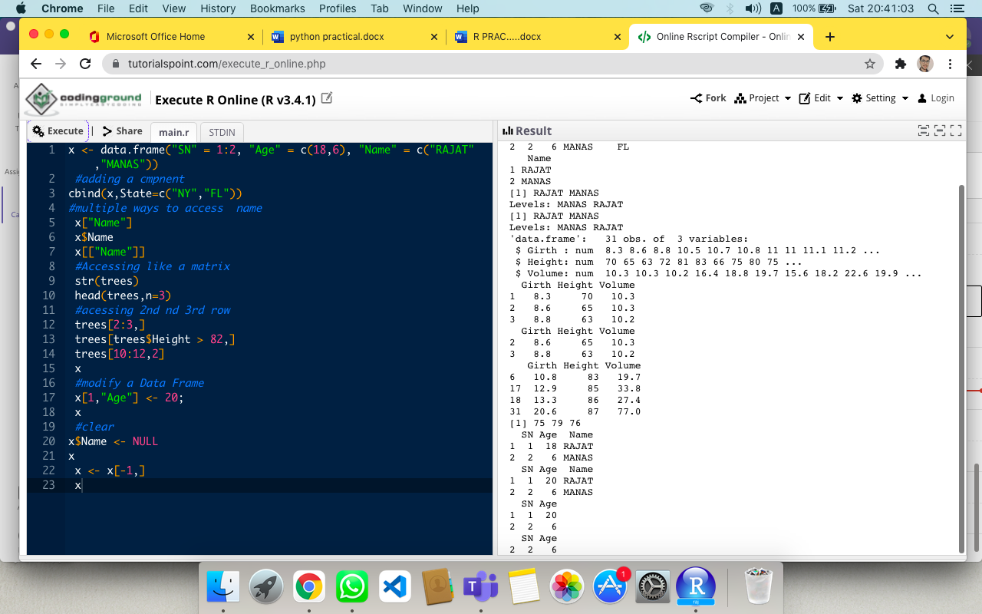

**15th**

d1=data.frame('SNo'=1:4,'age'=c(20,18,16,22),'name'=c('Rajat','Ram','yuvraj','Anuj'),'marks'=c(98,94,88,97))

str(d1)

print("Dataframe after sorting 'name' and 'mark'")

d2=d1[with(d1,order(name,marks)),]

d3=d1[with(d1,order(marks)),]

print(d2)

print(d3)

print(summary(d1))

print("Extractig specific columns:")

result=data.frame(d1$marks[d1$marks>90])

result=d1[1:3,]

print(result)

print("Extract 3rd and 5th row with 1st and 3rd column:")

result=d1[c(3,5),c(1,3)]

print(result)

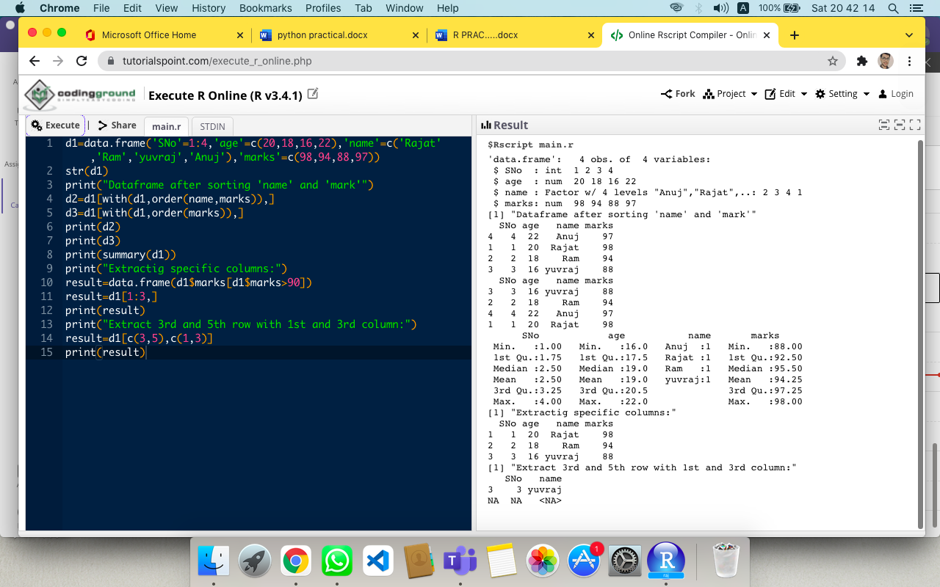

**16th**

v <- c(1,2,3,3,4,NA,3,2,4,5,NA,5)

fac=factor(v)

print("original factor ")

print(v)

print("levels of factor of the said vector")

print(levels(factor(v)))

summary(factor(v))

class(fac)

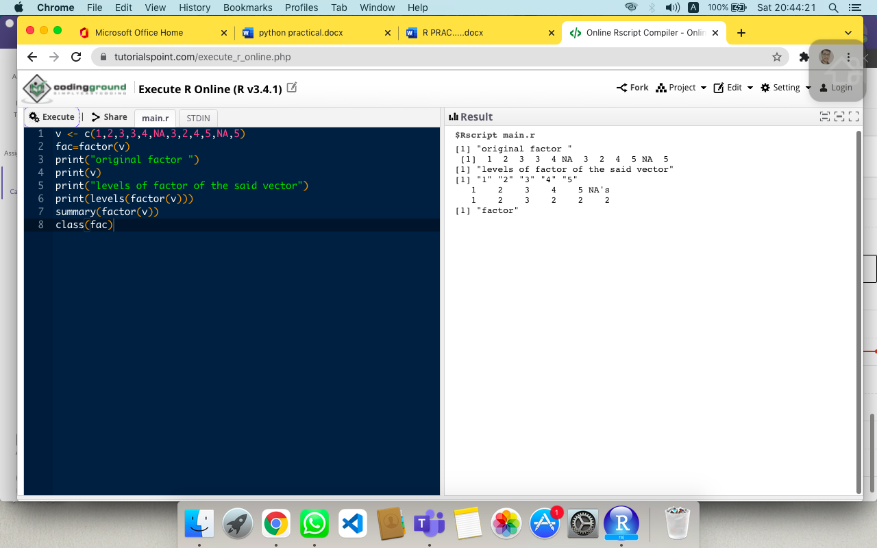

**17th**

Mons_v <- c("March","April", "January"," November"," January"," September"," October"," September"," November"," August"," February"," January"," November"," November"," February ","may"," August ","February"," July"," December"," August"," August"," September ","November ","September", "February", "April")

print("original factor ")

print(Mons_v)

f=factor(Mons_v)

print(" ordered factor of the said vector : ")

print(f)

print (table(f))

summary(f)

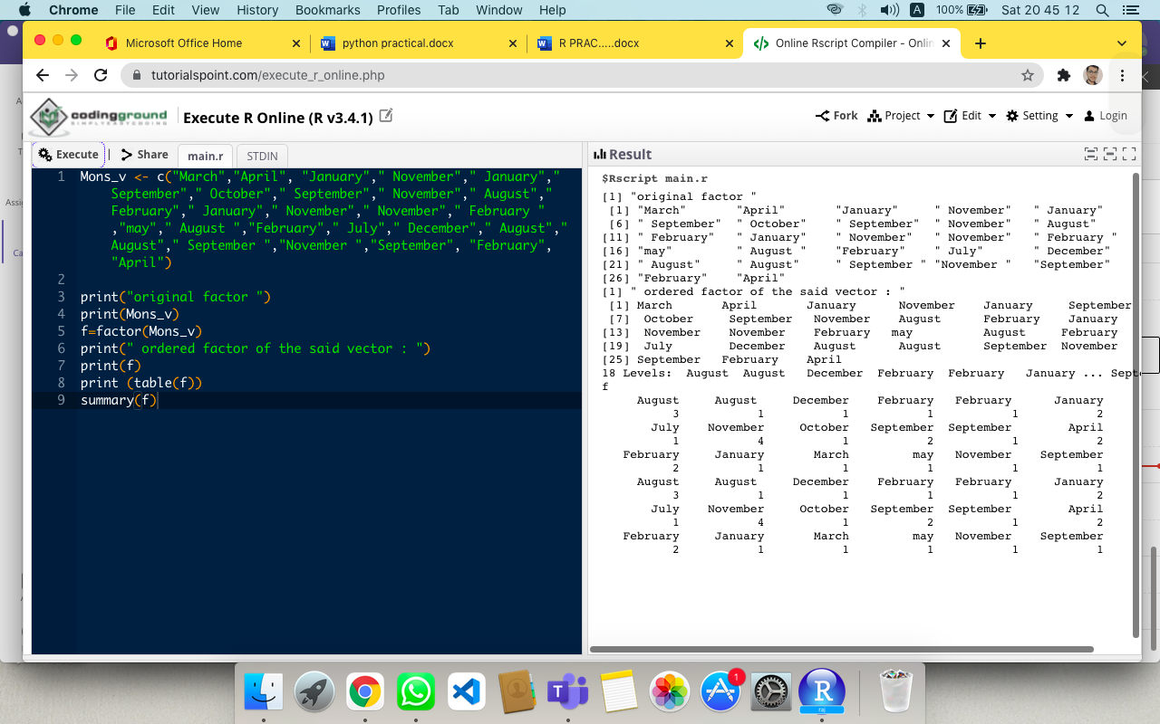

**18th**

data =women

print("women data set of height and weight :")

print(data)

height_f = cut(women$height,3)

print("factor corresponding to height :")

print(table(height_f))

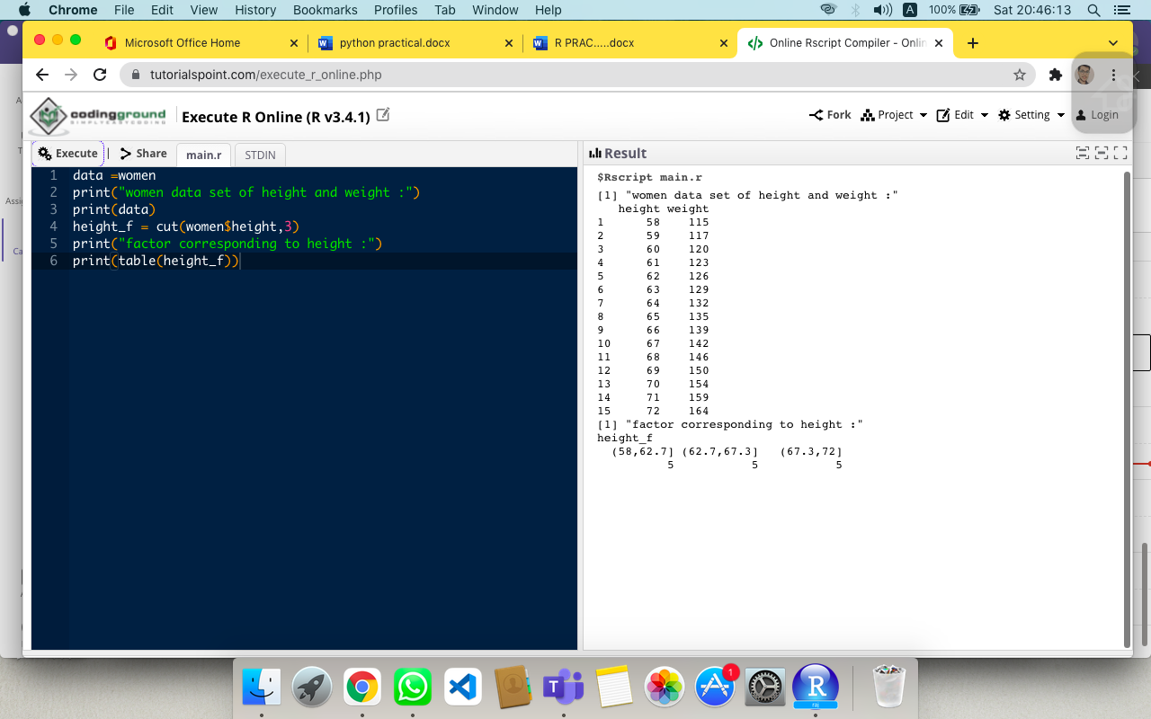

**19th**

v<-gl(3,4,labels=c("A","B","C"),ordered=TRUE)

print(v)

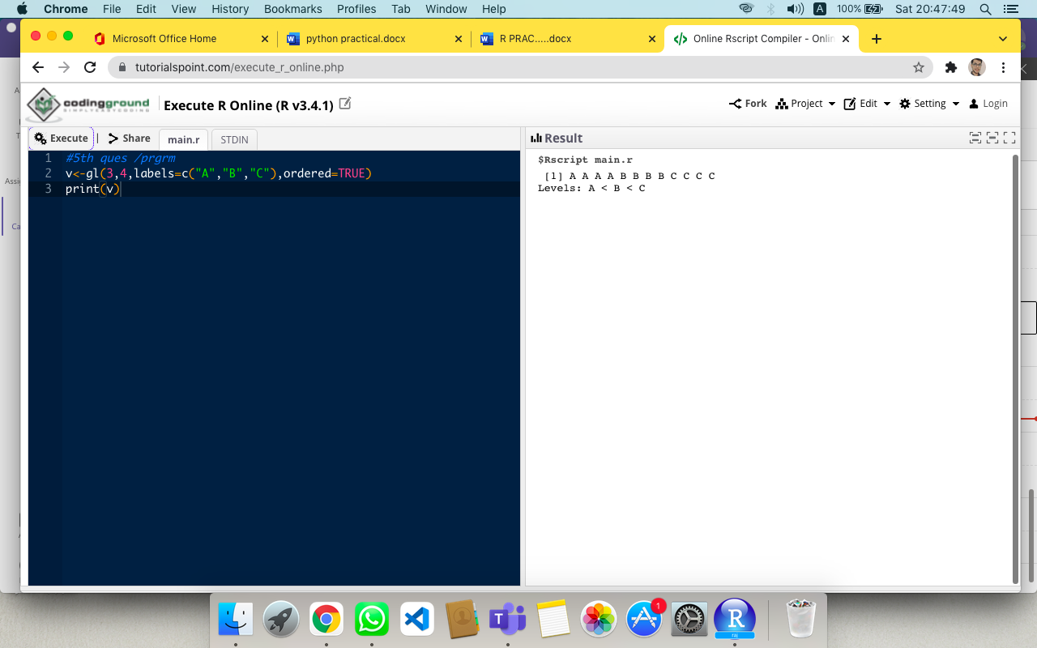

**20th**

v<-gl(3,4,labels=c("A","B","C"),ordered=FALSE)

print(v)

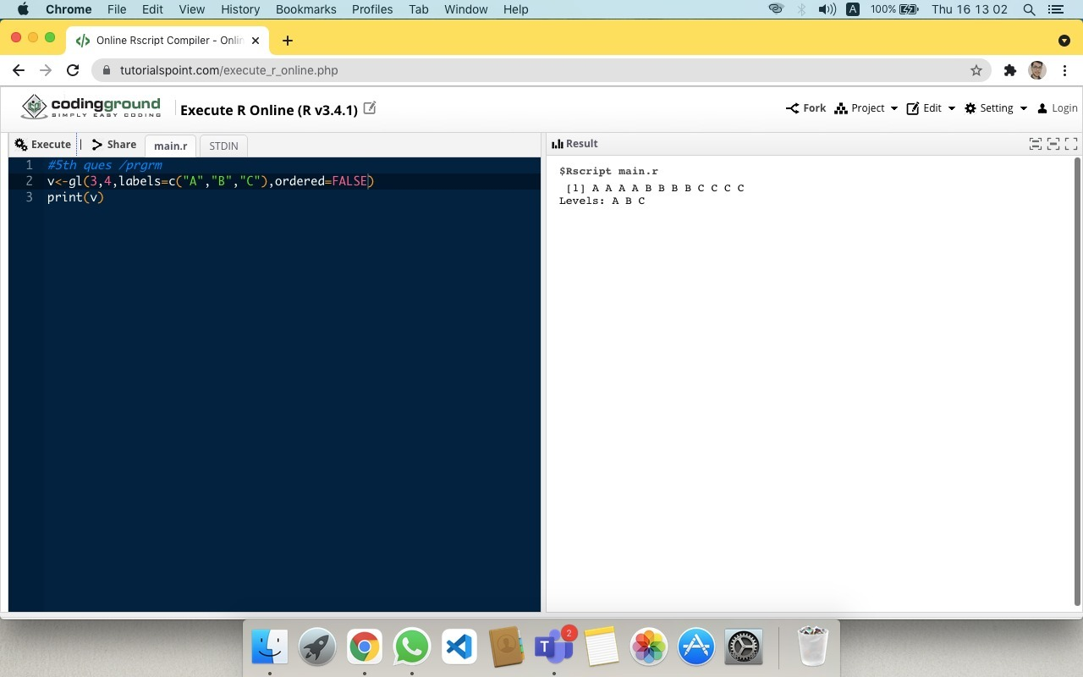

**21st**

data1=c(1,2,3,4,5,6,7,8,9,10,3)

print(data1)

data1_fac=factor(data1,levels=c(1,3,5,7,9),ordered=TRUE)

print(data1_fac)

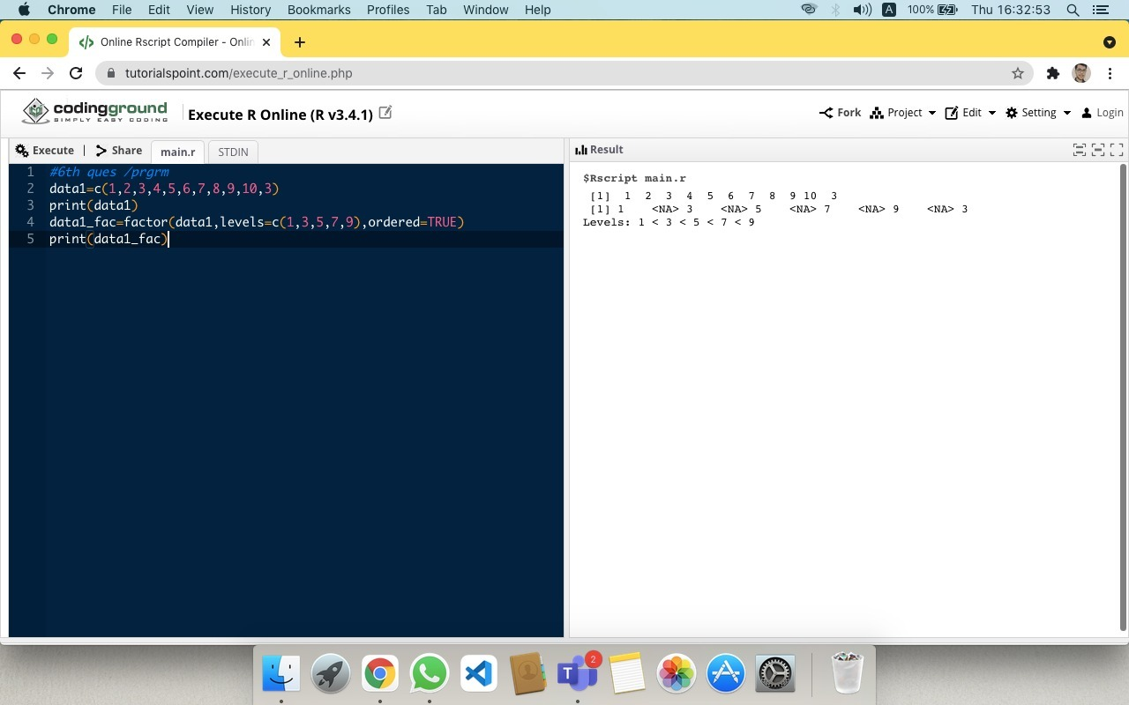

**22nd**

Thisarray <-c(1:9)

Thisarray

Multiarray <-array(Thisarray, dim = c(4,3,2))

Multiarray

Multiarray [2,3,2]

Multiarray [c(1),,1]

Multiarray [,c(1),1]

2%in%Multiarray

dim(Multiarray)

length(Multiarray)

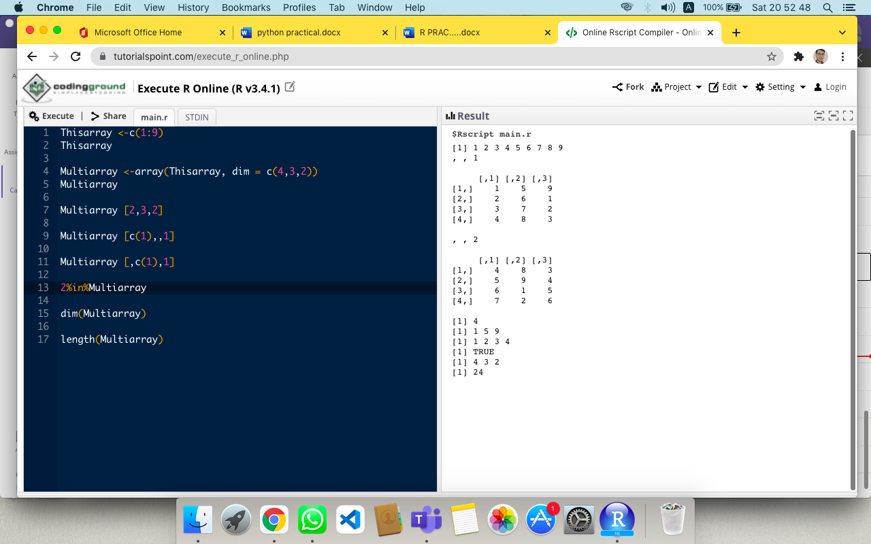

**23rd**

x= data.frame(

name = c('rajat', 'shashank', 'harshit', 'dhruv'),

age = c(19, 22, 20, 19),

rank_holder = c(1, NA , 2 , NA)

)

print("Original dataframe:")

print(x)

x[is.na(x)] = 3

print("After removing NA with 3, the new dataframe are :")

print(x)

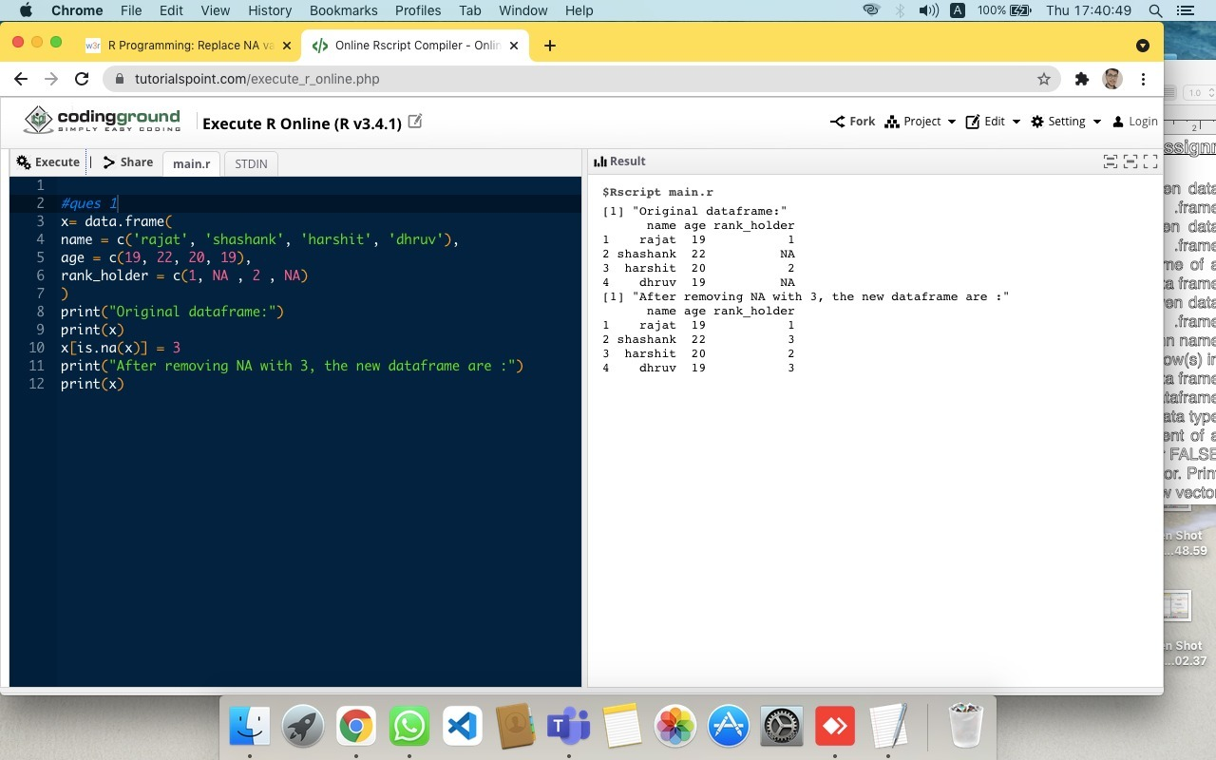

**24th**

x<-matrix(1:9, nrow=3,ncol=3)

print("Original matrix : ")

x

print("after change the column name : ")

colnames(x)<-c("c1","c2","c3")

x

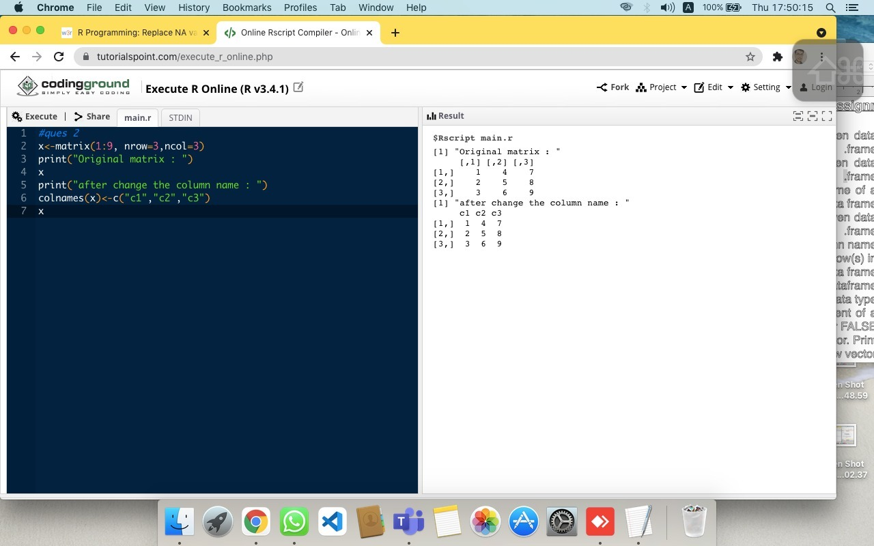

**25th**

x = data.frame(

name = c('rajat', 'shashank', 'harshit', 'dhruv'),

age = c(19, 22, 20, 19),

rank_holder = c(1, 3 , 2 , 4)

)

print("Original dataframe:")

print(x)

colnames(x)<-c("sname","sage","srank")

print(x)

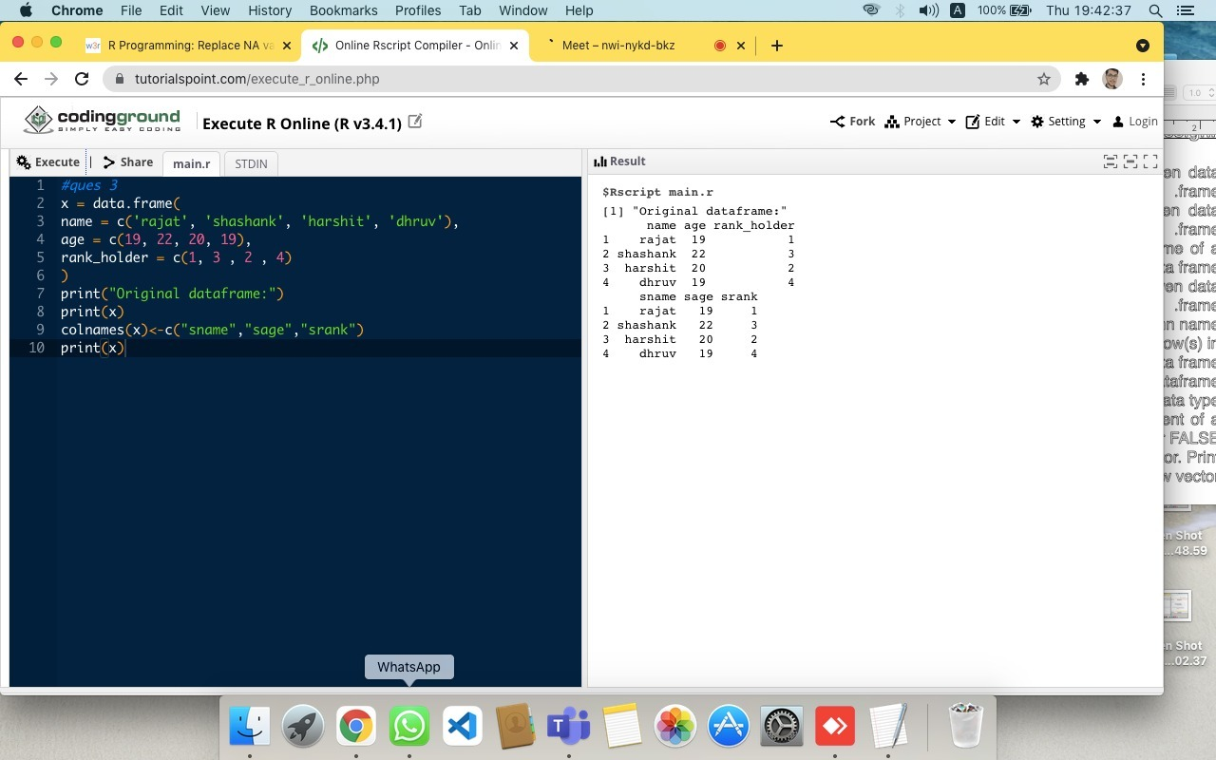

**26th**

x = data.frame(

name = c('rajat', 'shashank', 'harshit', 'dhruv'),

age = c(19, 22, 20, 19),

rank_holder = c(1, 3 , 2 , 4)

)

print("Original dataframe:")

print(x)

print("Select two random rows :")

print(x[sample(nrow(x), 2),])

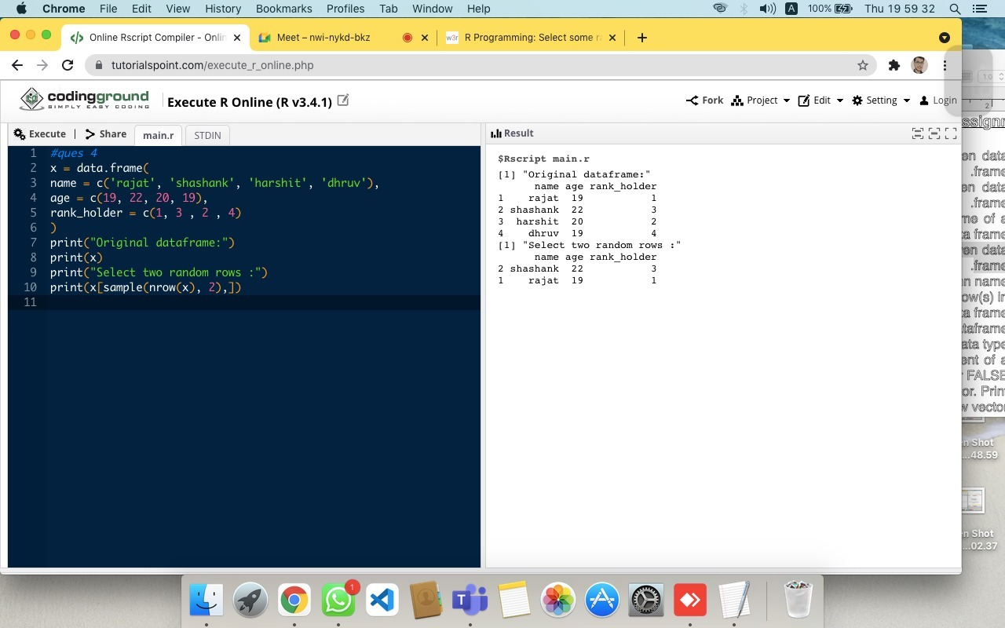

**27th**

x = data.frame(

name = c('rajat', 'shashank', 'harshit', 'dhruv'),

age = c(19, 22, 20, 19),

rank_holder = c(1, 3 , 2 , 4)

)

print("Original dataframe:")

print(x)

print("Reorder by column name:")

x = x[c("rank_holder","age","name")]

print(x)

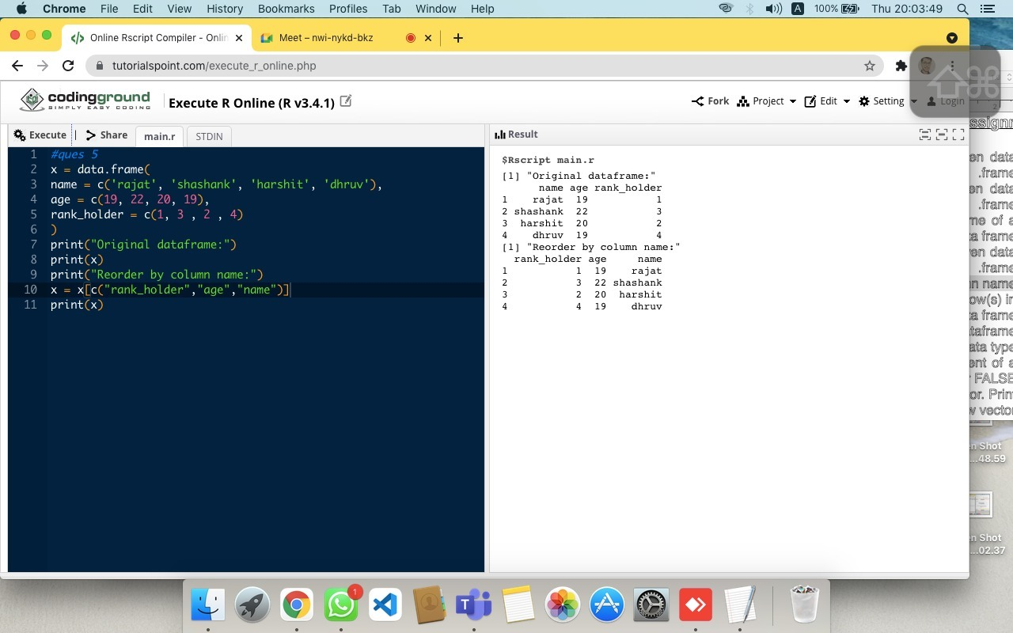

**28th**

x = data.frame(

name = c('rajat', 'shashank', 'harshit', 'dhruv'),

age = c(19, 22, 20, 19),

rank_holder = c(1, 3 , 2 , 4)

)

y = data.frame(

name = c('rajat', 'shashank', 'harshit', 'dhruv'),

age = c(19, 22, 20, 18),

rank_holder = c(1, 3 , 2 , 4)

)

print("Original dataframe:")

print(x)

print("Row(s) in first data frame that are not present in second data frame:")

print(setdiff(x,y))

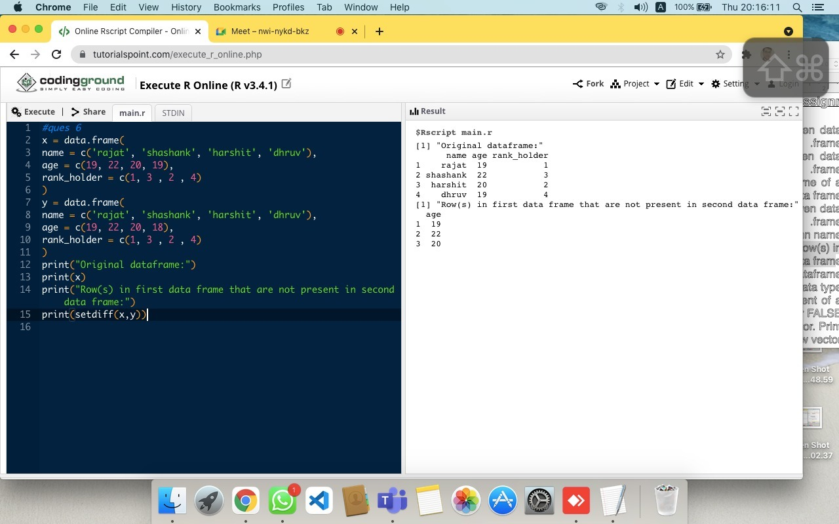

**29th**

x= data.frame(a=rnorm(3),

b=rnorm(3),

c=rnorm(3))

print("Original dataframe:")

print(x)

result = cor(x)

print("Correlation matrix:")

print(result)

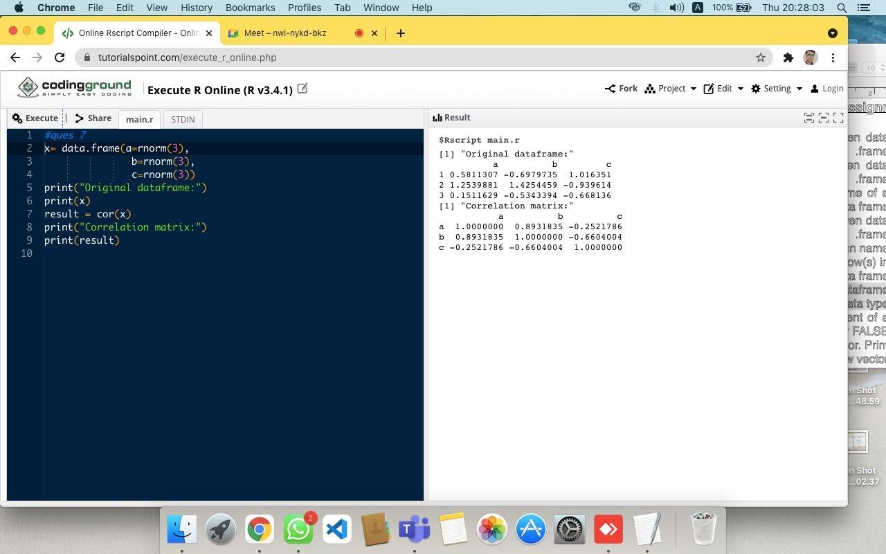

**30th**

x = c(15,26,9,7,10,0,9,15)

print("Original vector:")

print(x)

print("Test whether the value > 10 or not:")

print(x > 10)

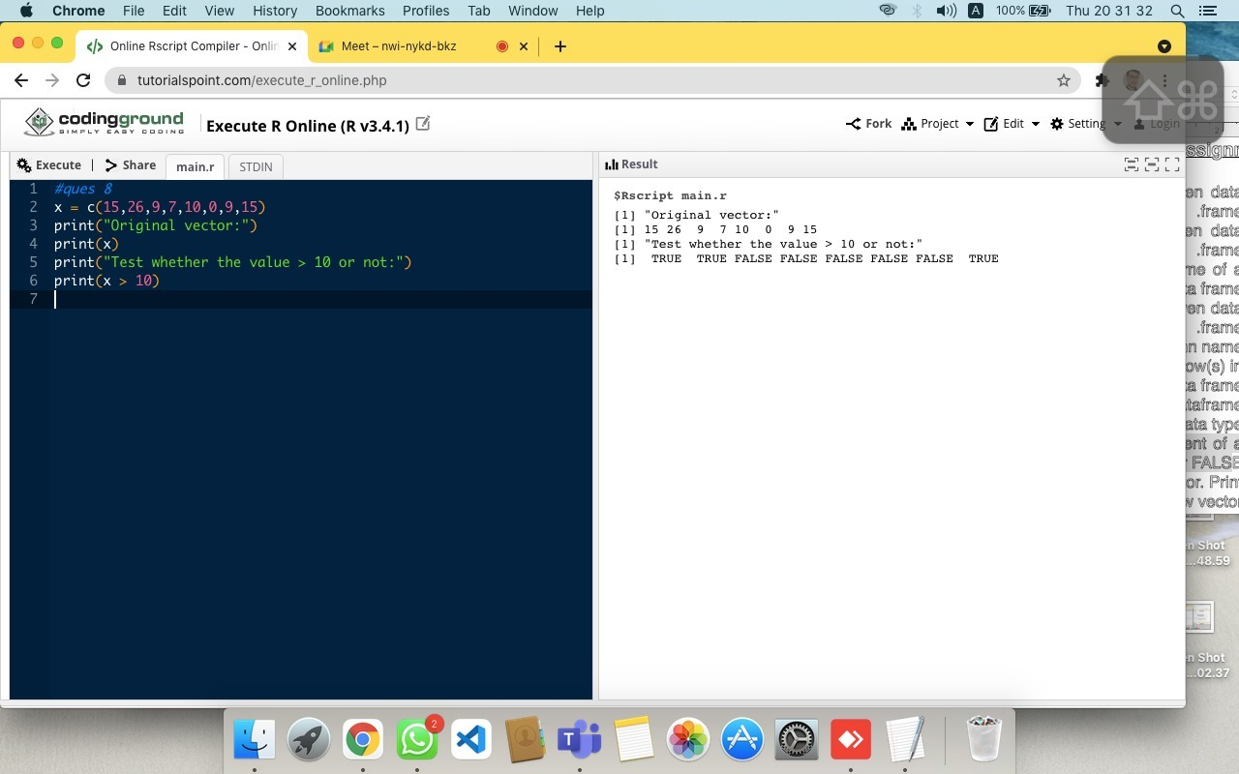

**31st**

x = c(1, 2, NULL, 3, 4, NULL)

print("Original vector:")

print(x)

y = (x+3)[(!is.na(x)) & x > 0]

print("New vector:")

print(y)

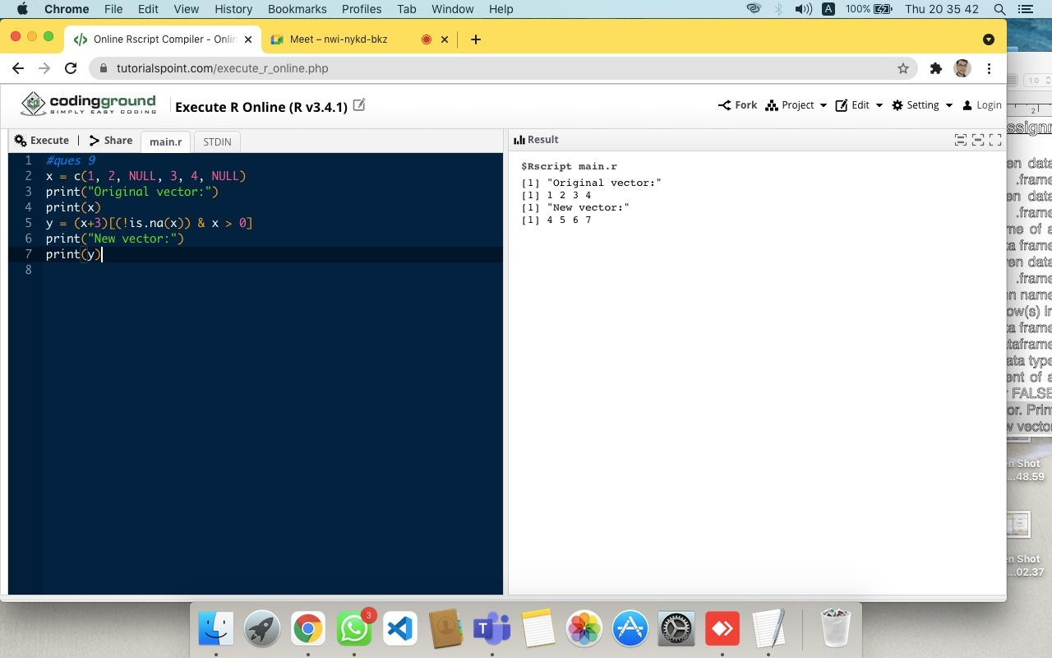

**32nd**

x<- c(1:4,NA,6:7,NA)

x

is.na(x)

df <- data.frame(col1 =c(1:3,NA),

col2 =c("this",NA,"is","text"),

col3 =c(TRUE,FALSE,TRUE,TRUE),

col4 =c(2.5,4.2,3.2,NA),

stringAsFactors = FALSE)

df

is.na(df)

is.na(df$col4)

which(is.na(x))

sum(is.na(df))

colSums(is.na(df))

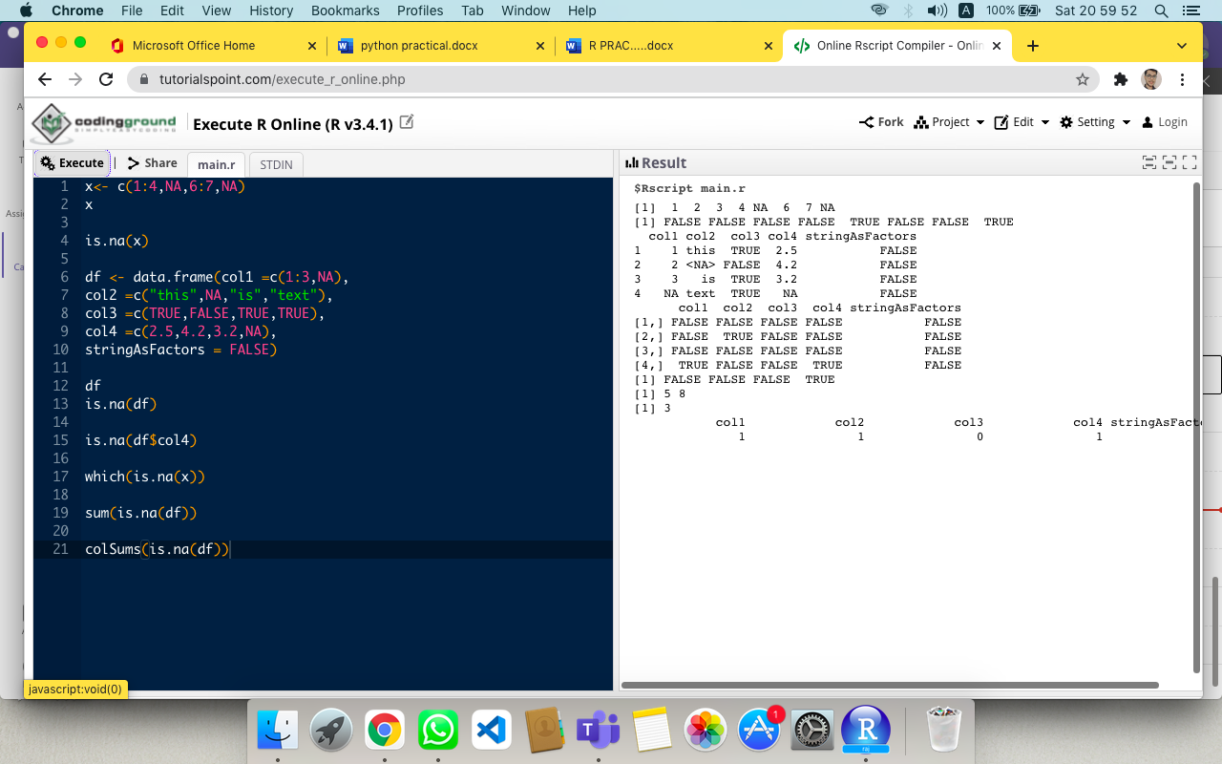

**33rd**

v<-c(17,25,38,13,41)

t<- c(22,19,36,19,23)

m<-c(25,14,16,34,29)

plot(v,type='o', col="red",xlab="Month", ylab="Article written" , main= "Article written chart")

lines(t,type="o",col = "blue")

lines(m,type="o",col = "green")

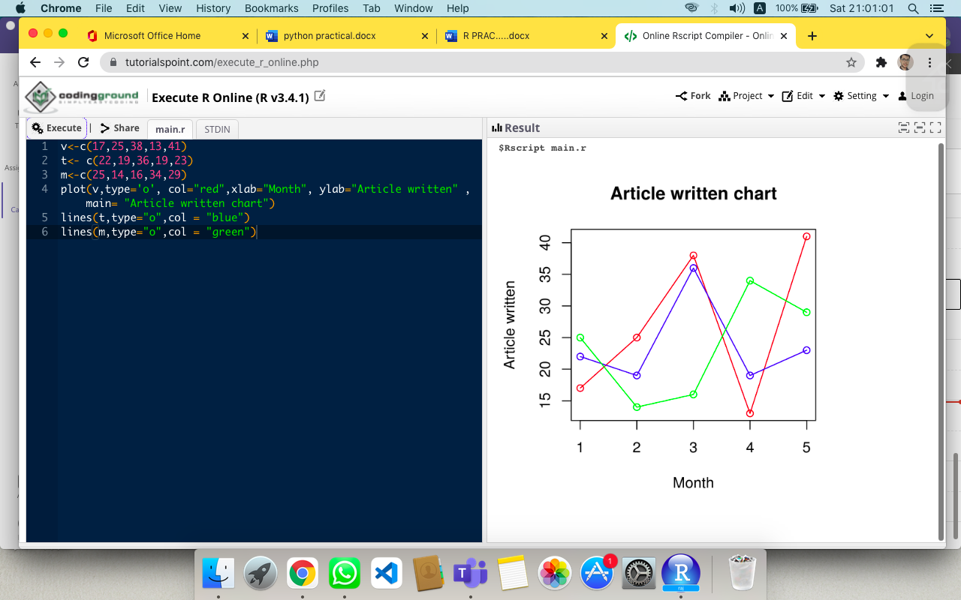

**34th**

A <- c(17,32,8,33,1)

barplot(A , xlab = "x-axis",ylab= "y-axis",main= "Bar-chart")

barplot(A, horiz = TRUE,xlab = "x-axis",ylab= "y-axis",main= "Bar-chart")

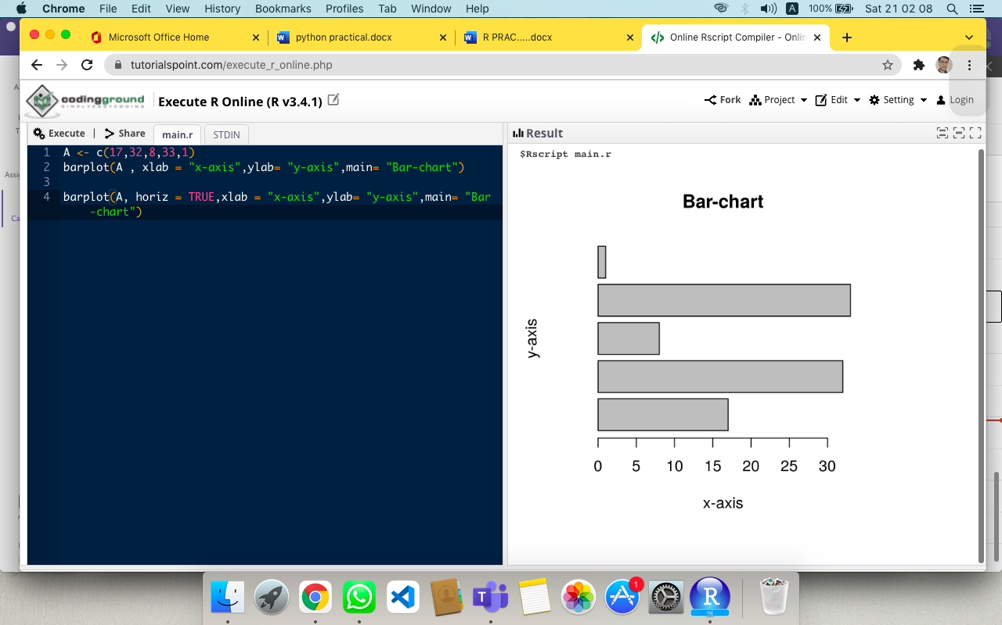

**35th**

#input stata file

library(haven)

mydata <- read_dta("/Users/macebook/Downloads/airline.dta")

mydata

write_dta (mydata,"/Users/macebook/Downloads/airline.dta")

write_dta

# export data frame to stata binary format

summary(mydata)

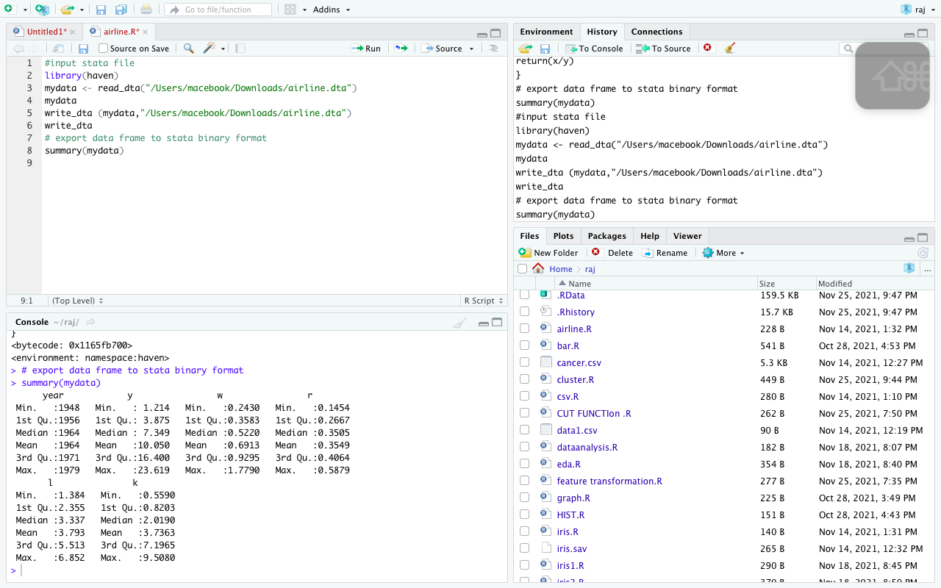

**36th**

A <- c(17,32,8,33,1)

B<- c("jan","Feb","mar","April","may")

barplot(A, names.arg = B ,xlab= "Month", ylab = "Articles", col = "red", main= "GeeksforGeeks-Article chart")

Colors c("black","pink","blue")

Months <- c("Mar","Apr","May","Jun")

regions <- c("East","West","North")

Values <- matrix(c(2,9,3,11,9,4,8,7,3,10,5,2,8,10,11), nrow= 3, ncol = 5, byrow =TRUE)

barplot(Values ,main = "Total Revenue",names.arg = months ,xlab= "Month", ylab= "Revenue",col= Colors,beside = TRUE)

legend("topleft" , regions , cex = 0.7 , fill = Colors)

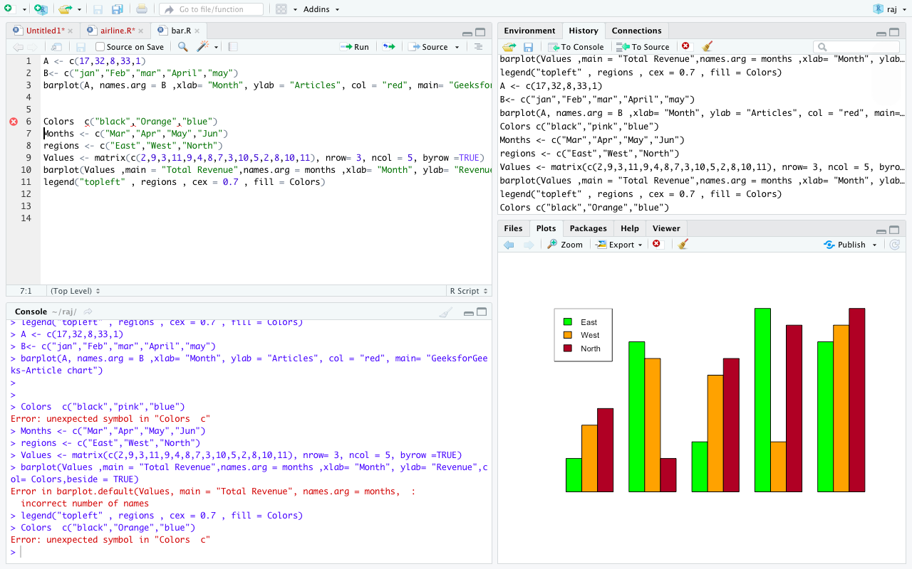

**37th**

install.packages("Cluster")

install.packages("ClusterR")

install.packages("factoextra")

install.packages("gridExtra")

library(tidyverse)

library(cluster)

library(gridExtra)

library(factoextra)

mydata <- data('USArrests')

d_frame <- USArrests

d_frame <- na.omit(d_frame) #Removing the missing values

head(d_frame)

kmeans(d_frame)

kmeans2 <- kmeans(d_frame, centers = 2, nstart = 25)

str(kmeans2)

print(kmeans2)

fviz_cluster(kmeans2, data = d_frame)

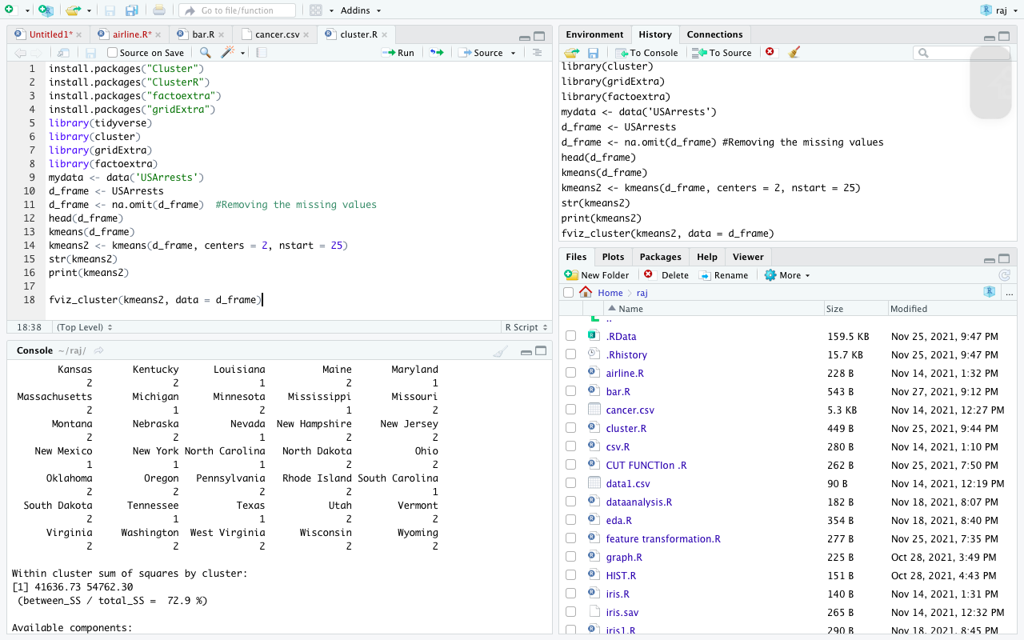

**38th**

df=c(2,3,4)

df=read.csv('/Users/macebook/Downloads/iris.sav')

df

ls(df)

str(df)

names(df)

dim(df)

class(df)

head(df,10)

df=read.csv('/Users/macebook/Downloads/iris.sav')

df

df=read.csv('/Users/macebook/Downloads/iris.sav',header=FALSE)

df

write.csv(df,"iris.sav")

df=read.csv

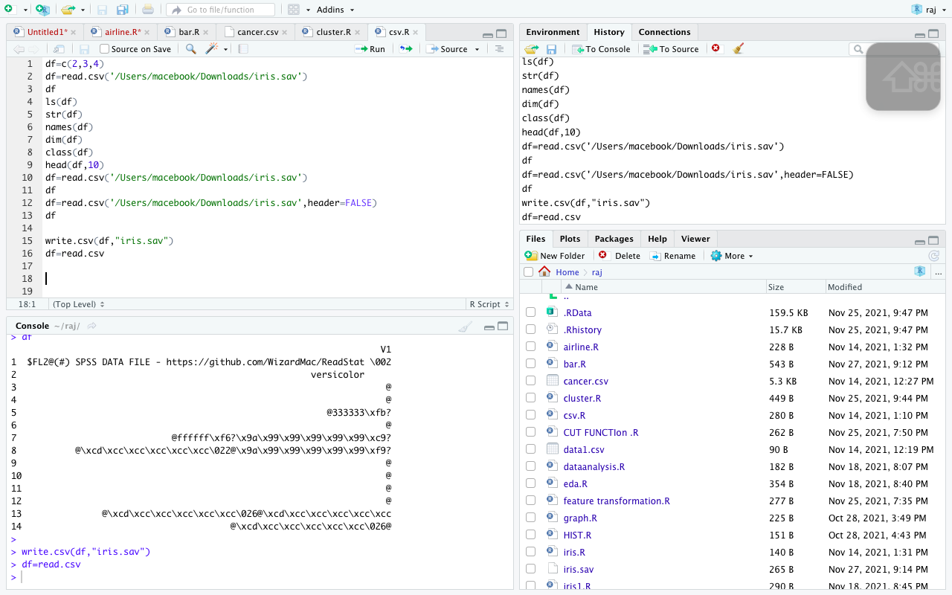

**39th**

#cut function for modifying the attributes for grouping the dataset

data= women

print("women data set of height and weights :")

print(data)

height_f = cut(women$height,2)

print("factor correspending to height :")

print(table(height_f))

data1 = airquality

data1

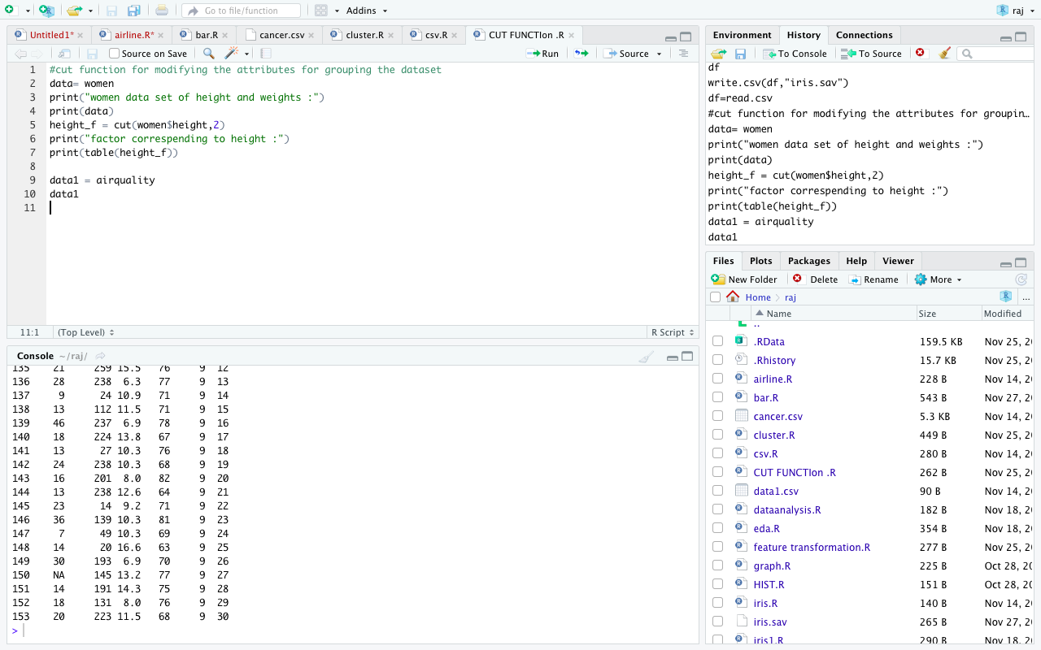

**40th**

str(Titanic)

apply(Titanic,1,sum)

head(Titanic)

tail(Titanic)

head(airquality)

is.na(Titanic)

barplot(table(airquality$Ozone))

barplot(table(airquality$Solar.R))

summary(airquality)

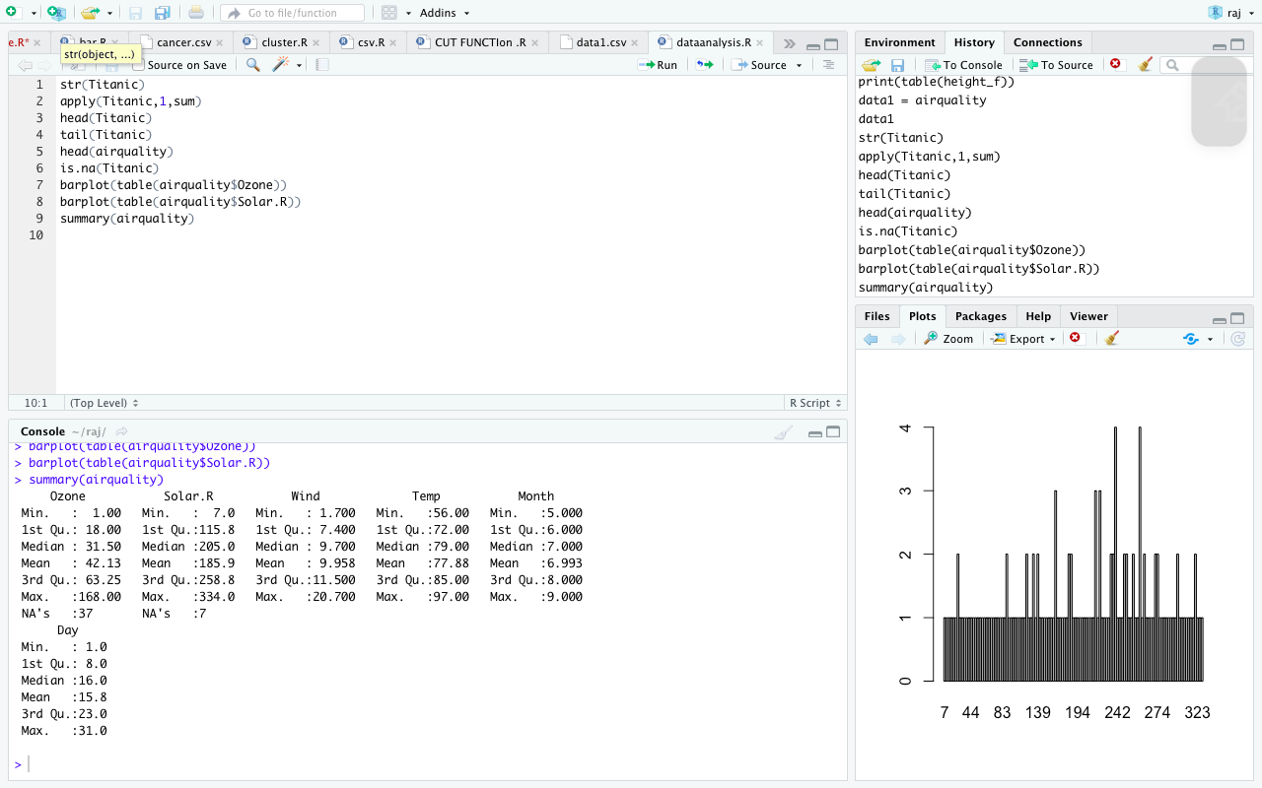

**41st**

#install.packages("tidyverse")

#install.packages("funModeling")

#install.packages("Hmisc")

library(tidyverse)

library(funModeling)

library(Hmisc)

data<- airquality

colSums(is.na(airquality))

sum(is.na(airquality))

mean(airquality$Solar.R,na.rm=TRUE)

data

data$Solar.R[is.na(data$Solar.R)]<- mean(data$Solar.R, na.rm = TRUE)

data$Solar.R

sum(is.na(data))

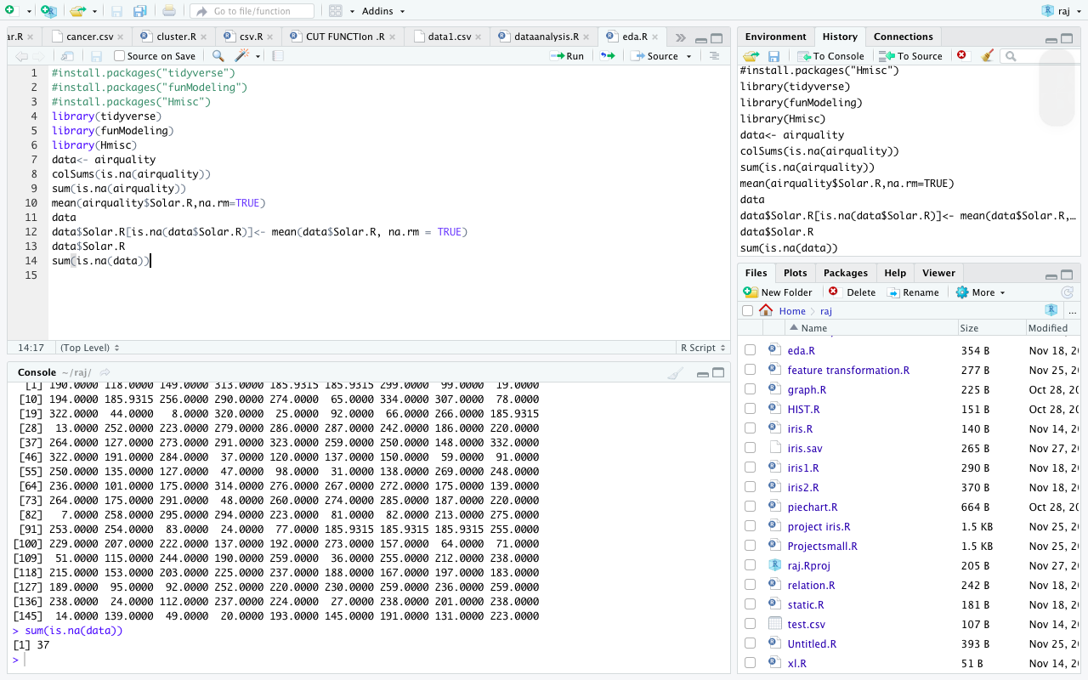

**42nd**

data = iris

dim(data)

head(data)

summary(data)

data

install.packages("e1071")

library(e1071)

skewness(data$Sepal.Length,type = 2)

data$sq_len <- sqrt(data$Sepal.Length)

data$cub_len <- data$Sepal.Length ^(1/3)

skewness(data$sq_len,type = 2)

skewness(data$cub_len,type = 2)

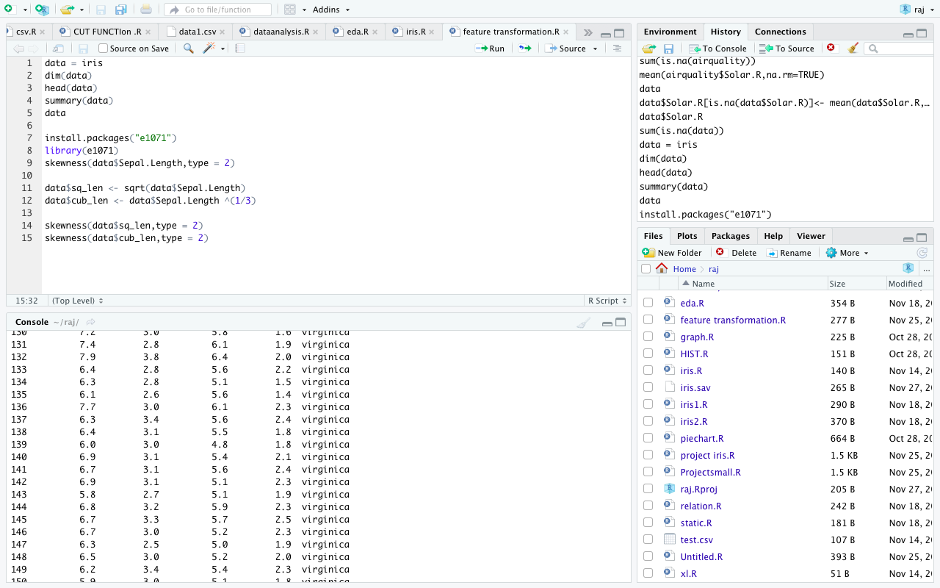

**43rd**

library(haven)

my_data=read_sav("/Users/macebook/Downloads/iris(1).sav")

my_data

write_sav(my_data,"/Users/macebook/Downloads/iris(1).sav")

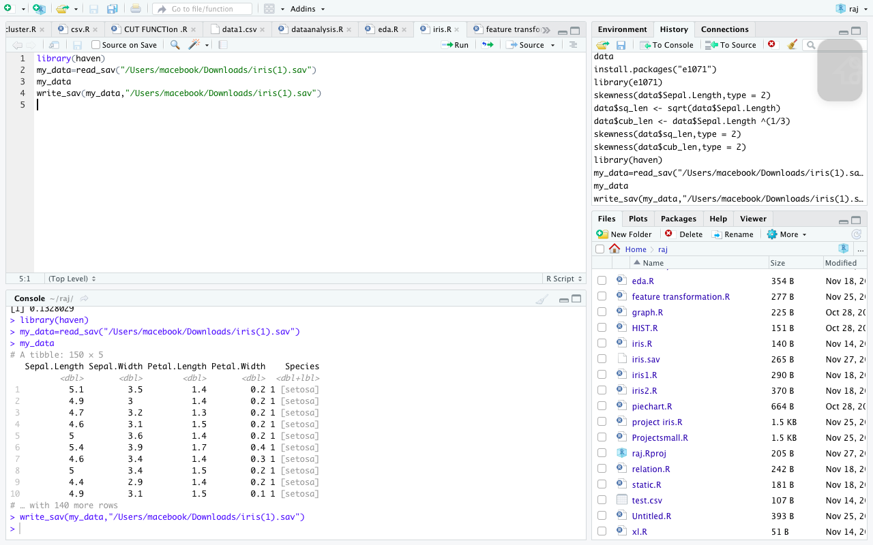

**44th**

V <- c(19,23,11,5,16,21,32,14,19,37,39)

hist(V, xlab = "No of articles",col= "yellow",border = "black",xlim = c(0,50),

ylim = c (0,5),breaks = 5)

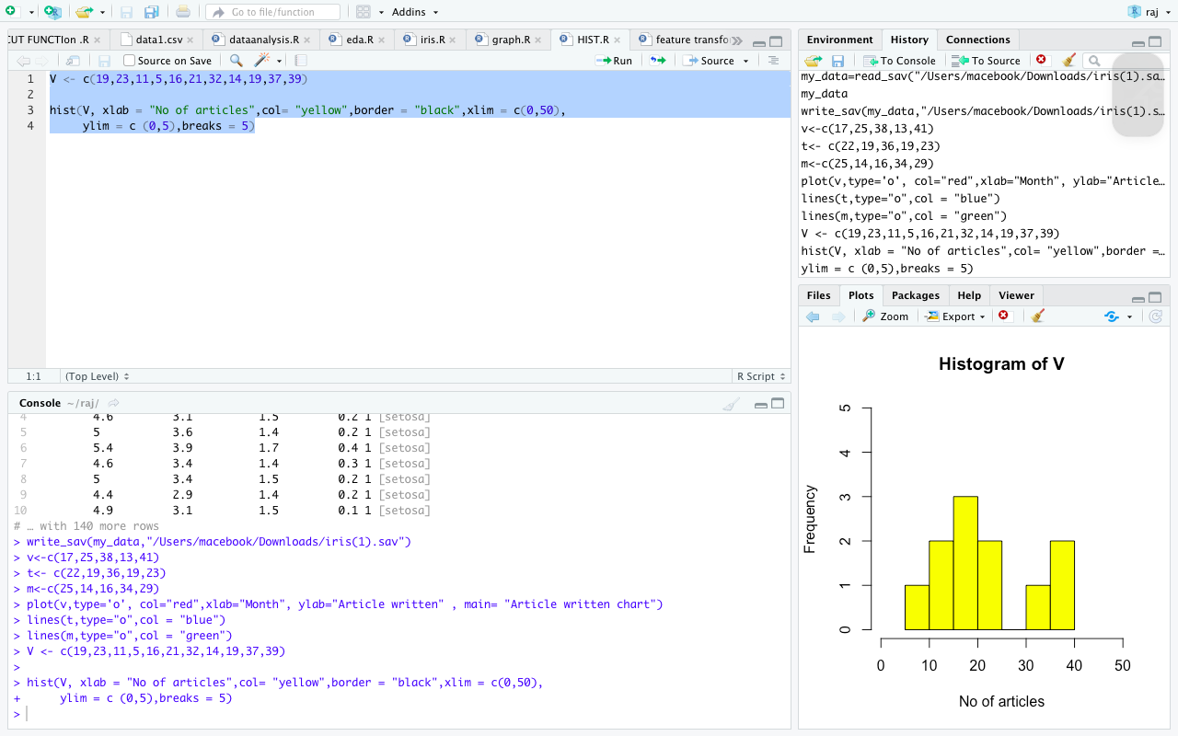

**45th**

geeks <- c(23,56,20,63)

lebels <- c( "Mumbai", "Pune", "Chennai", "Bangalore")

pie(geeks,lebels)

geeks<- c(23, 56, 20, 63)

labels <- c("Mumbai", "Pune", "Chennai", "Bangalore")

# Plot the chart with title and rainbow color pallet.

pie(geeks, labels, main = "City pie chart", col = rainbow(length(geeks)))

geeks <- c(23, 56, 20, 63)

labels <- c("Mumbai", "Pune", "Chennai", "Bangalore")

piepercent<- round(100 * geeks / sum(geeks), 1)

# Plot the chart.

pie(geeks, labels = piepercent, main = "City pie chart", col = rainbow(length(geeks)))

legend("topright", c("Mumbai", "Pune", "Chennai", "Bangalore"), cex = 0.5, fill = rainbow(length(geeks)))

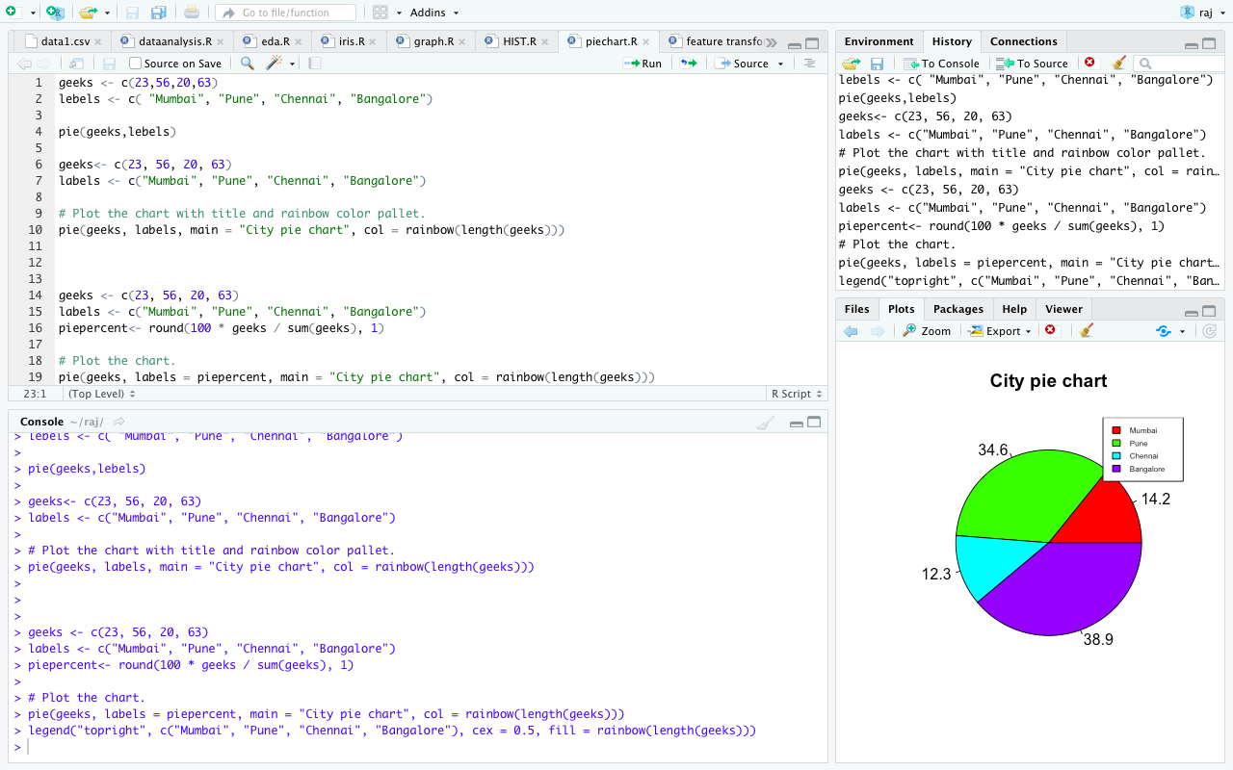

**46th**

names(list)

plot(iris[-5])

print(iris)

with(iris, cor(Petal.Width, Petal.Length))

iris.cor<- cor(iris[-5])

print(iris.cor)

subset(iris,Petal.Length <2)[,"Species"]

subset(iris,Species=="setosa")[1:5,1]

iris1=subset(iris,Species=="setosa")[1:5,1]

print(iris1)

corr <- cor(iris[,1:4])

print(corr)

round(corr,1)

aggregate(x=iris,by=list(iris$Petal.Length),FUN = "mean")

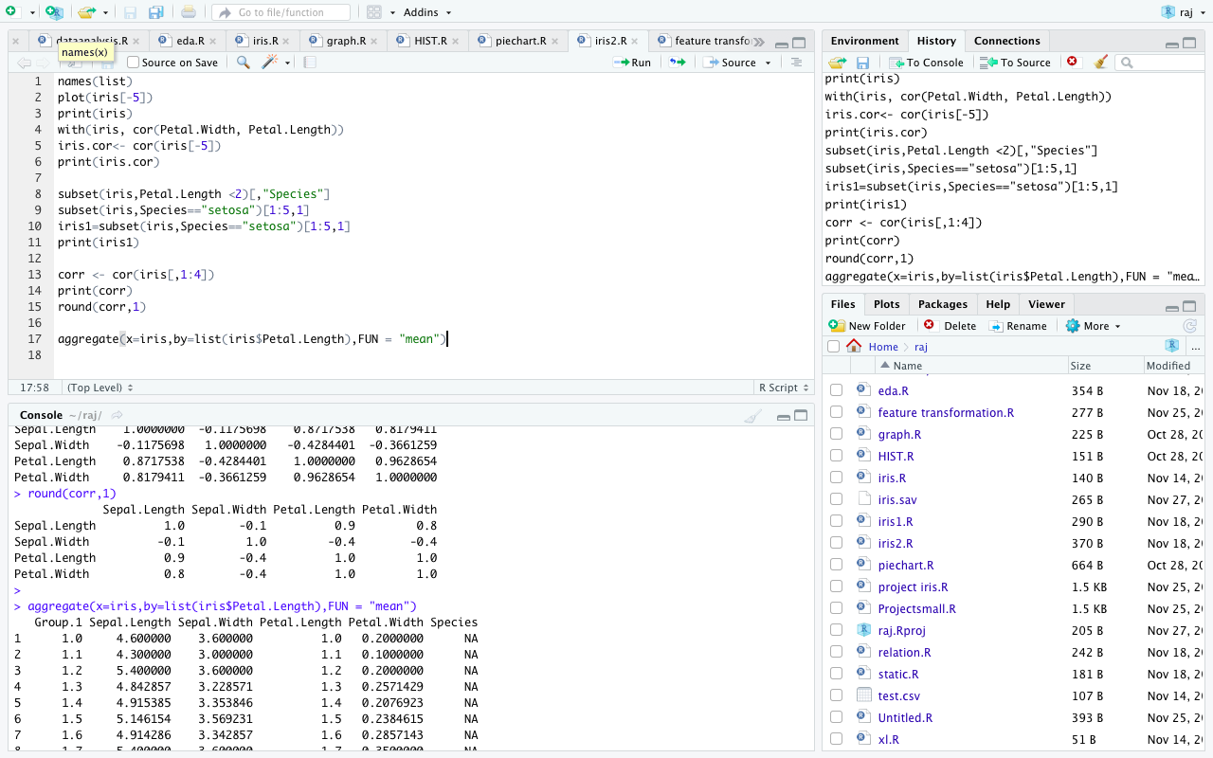

**47th**

str(Titanic)

apply(Titanic,1,sum)

head(Titanic)

tail(Titanic)

head(airquality)

is.na(Titanic)

barplot(table(airquality$Ozone))

barplot(table(airquality$Solar.R))

summary(airquality)

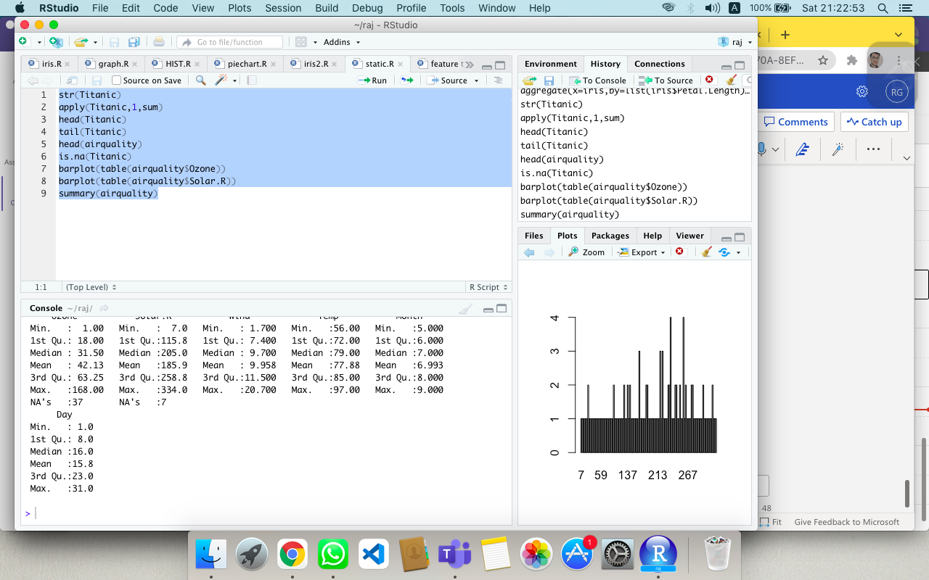

**48th**

#installed.packages("caret")

#installed.packages("randomForest")

library(caret)

library("randomForest")

data("iris")

dataset <- iris

#create a list of 80 % of the rows in the original dataset we can use for training

validation_index <- createDataPartition(data$Species, p= 0.80,list = FALSE)

#select 20% of the data for validation

validation <- dataset[-validation_index,]

#use the remaining 80% of the data to trainingf the models

dataset <- dataset[-validation_index,]

summary(dataset)

dim(dataset)

sapply(dataset,class)

levels(dataset$Species)

# Run algorithm using 10 fold cross validation

control <- trainControl(method="cv", number=10 )

metric <- "Accuracy"

#a) linear algorithms

set.seed(9)

fit.lda <- train(Species~.,data=dataset, method="lda", metric= metric,trControl= control)

#b) nonlinear algorithms

#CART

set.seed(3)

fit.cart <- train(Species~.,data=dataset, method="rpart", metric= metric,trControl= control)

#KNN

set.seed(1)

fit.knn <- train(Species~.,data=dataset, method="knn", metric= metric,trControl= control)

#c)advanced algorithms

#svm

set.seed(4)

fit.svm <- train(Species~.,data=dataset, method="svmRadial", metric= metric,trControl= control)

#Random Forest:

set.seed(7)

fit.rf <- train(Species~.,data=dataset, method="rf", metric= metric,trControl= control)

#summarize accuracy of models

results <- resamples(list(lda=fit.lda, cart=fit.cart, knn=fit.knn, svm=fit.svm, rf=fit.rf))

summary(results)

#estimate skill of LDA on the validation dataset

predictions <- predict(fit.lda,validation)

confusionMatrix(predictions,validation$Species)

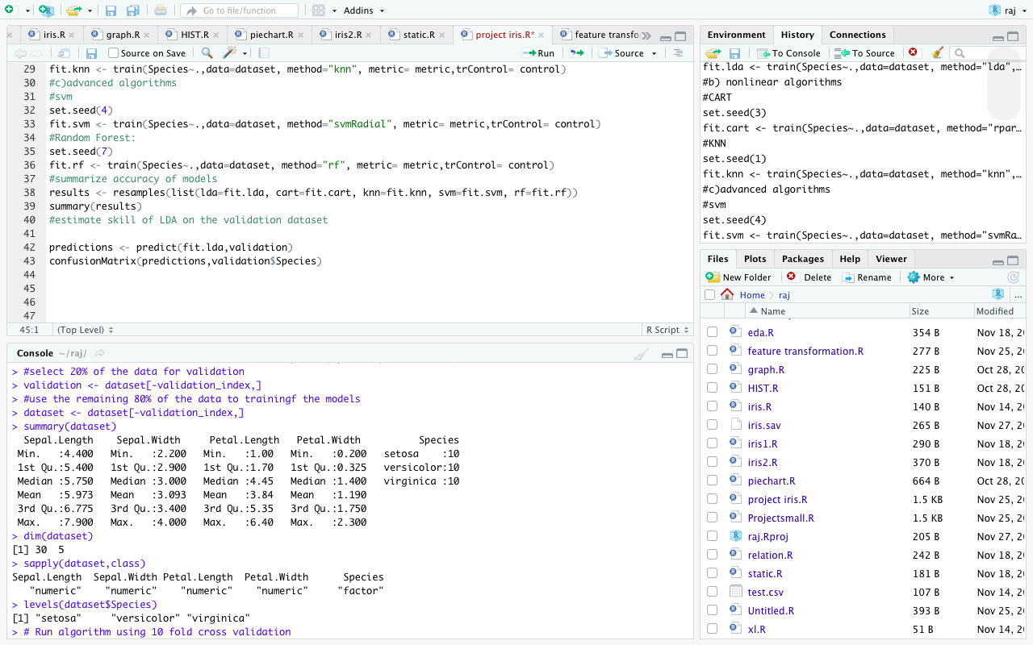

**49th**

x <-c(151,174,138,186,128,136,179,163,152,131)

y <-c(63,81,56,91,47,57,76,72,62,48)

#Apply the lm() function

relation<- lm(y-x)

print(summary(realtion))

airquality

relation2 <- lm(airquality$Temp-airquality$Month)

print(summary(relation2))

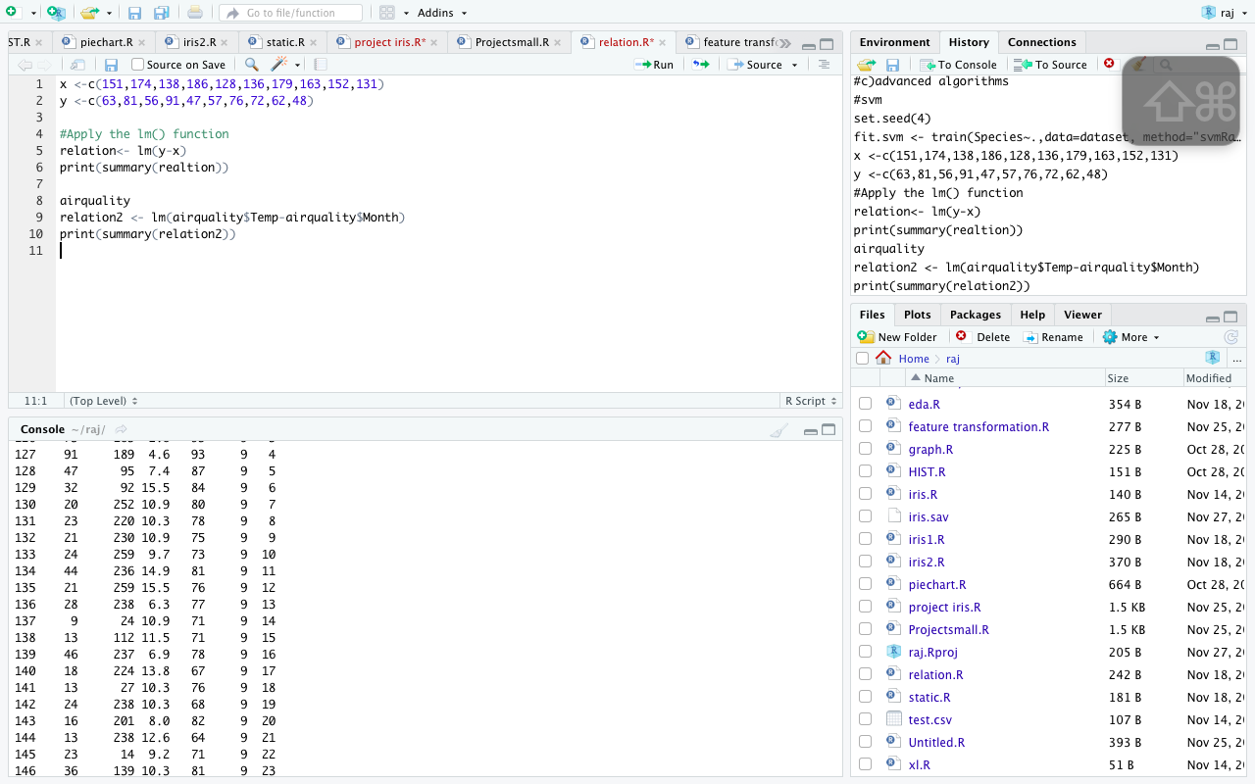

**50th**

library(haven)

my_data=read_sav("/Users/macebook/Downloads/iris(1).sav")

my_data

write_sav(my_data,"/Users/macebook/Downloads/iris(1).sav")

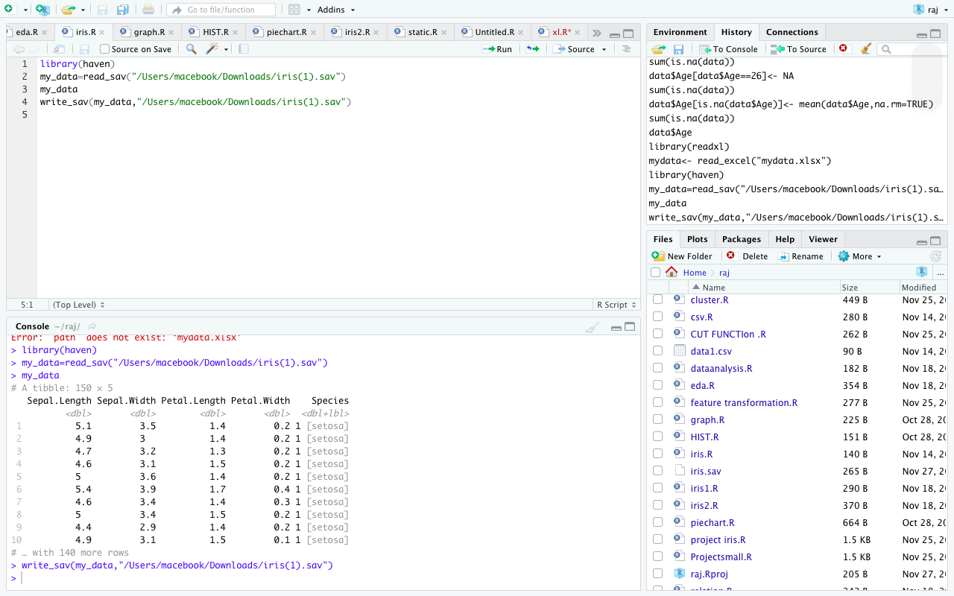 ”THANKYOU MAM”